
gf
Touchstones Project REACH
(Religious Education Arts Clearing House)

Lifespan RE Resources for Joy

Introduction
The content of this packet is shaped by the theme of Joy. It is grounded primarily in our first and third principle and in our first and sixth source.

- 1st principal: The inherent worth and dignity of every person / We believe that each and every person is important.
- 3rd principle: Acceptance of one another and encouragement to spiritual growth in our congregations / We believe that we should accept one another and keep on learning together.

- 1st source: Direct experience of that transcending mystery and wonder, affirmed in all cultures, which moves us to a renewal of the spirit and an openness to the forces which create and uphold life / The sense of wonder we all share.
- 6th source: Spiritual teachings of earth-centered traditions which celebrate the sacred circle of life and instruct us to live in harmony with the rhythms of nature / The harmony of nature and the sacred circle of life.

While the word joy is distinct from the word happiness, they are often used as synonyms. Further, for children, having fun is often how they experience joy. All three words and concepts are necessary to explore this theme. One activity that can elicit joy is play, another is service. Actions that can bring joy to others include forgiveness and kindness. A helpful resource for kindness is 60 Acts of Kindness for Kids to Do to Make the World a Better Place at https://www.rd.com/article/acts-of-kindness-for-kids/.

Given the struggles in society including the Covid pandemic, lifting up the importance of joy is important.

An excellent resource is the book, Awakening Joy for Kids: A Hands-On Guide for Grown-Ups to Nourish Themselves and Raise Mindful, Happy Children by James Baraz and Michele Lilyanna. Their suggestions include
- Setting positive intentions
- Practicing mindfulness
- Cultivating gratitude
- Having compassion for oneself and others
The book also includes a teachers’ guide.
Author Michele Lilyanna offers ideas from the book at https://awakeningjoy.info/teacherForKidsTenSteps.php.

The website, Miracle, has useful information about the importance of joy in child development. They note that being joyful reduces anxiety, boosts learning ability, and encourages children to try new things. Parents can cultivate joy in their children by
- Finding Joy in Their Own Lives
- Creating a Joyful Home
- Redirecting Children’s Negative Thoughts
- Managing Their Child’s Time and Responsibilities
- Promoting Outdoor Experiences
See the details at https://www.miracle-recreation.com/blog/importance-of-joy-child-development/

Another resource, one based in Buddhist thought, is the book, Happiness: A Guide to Developing Life's Most Important Skill by Matthieu Ricard. This relates to leading a joyful life. His key ideas are as follows:
- Real happiness is a long-term mental state we have to consciously work toward.
- Seek happiness within yourself, not from the outside world.
- Happiness is not the same thing as pleasure.
- Happiness isn’t about avoiding suffering. It’s about freeing yourself from worries about life.
- The ego is the true source of suffering and conflicted emotion.
- Free yourself from your own ego.
- Your thoughts and emotions can be your [best friends or] worst enemies.
- Examine your negative thoughts and emotions so you can overcome them and achieve inner peace.
For a good summary of these see https://lifeclub.org/books/happiness-matthieu-ricard-review-summary. Also see the text of the TED Global interview of Matthieu Ricard, “Want to be happy? Slow down,” by journalist and writer Pico Iyer at https://ideas.ted.com/want-to-be-happy-slow-down/. Finally, you can find information about Ricard’s TED Talk below at 8.10.

Another resource is Action for Happiness (https://actionforhappiness.org/). This organization, which is based in England, was founded in 2010. The Dalai Lama, their patron, has stressed both kindness and happiness in his teachings. Consider the following quotes by the Dalai Lama: “My religion is very simple. My religion is kindness,” and “Happiness is not something ready-made. It comes from your own actions.”

Related to this is The Book of Joy: Lasting Happiness in a Changing World by the Dalai Lama and Desmond Tutu. They offer eight pillars related to cultivating joy: Perspective, Humility, Humor, Acceptance, Forgiveness, Gratitude, Compassion, and Generosity. We proposed six more in the piece in the Touchstones Journal section on Faith & Theology: Mindfulness, Embodiment, Service, Justice, Holy Discontent, and Beloved Community

Action for Happiness offers the following 10 keys for happiness. See https://actionforhappiness.org/10-keys. Click on each square there for more details about a key.
- Giving: Do things for others
- Relating: Connect with people
- Exercising: Take care of your body
- Awareness: Live life mindfully
- Trying out: Keep learning new things
- Direction: Have goals ro look forward
- Resilience: Find ways to bounce back
- Emotions: Look for what’s good
- Acceptance: Be comfortable with who you are
- Meaning: Be part of something bigger

Their resources include monthly calendars on-line at https://www.actionforhappiness.org/calendars with the following themes:
- January: Happier New Year (key: Happiness)
- February: Friendly February (key: Relating)
- March: Mindful March (key: Awareness)
- April: Active April (key: Exercising)
- May: Meaningful May (key: Meaning)
- June: Joyful June (key: Emotions)
- July: Jump Back Up July (key: Resilience)
- August: Altruistic August (key: Giving)
- September: Self-Care September (key: Acceptance)
- October: Optimistic October (key: Direction)
- November: New Ways November (key: Trying Out)
- December: Do Good December (key: Kindness)

Another resource for monthly happiness calendars can be found at the Greater Good Science Center at https://greatergood.berkeley.edu/tag/happiness+calendar.

While the calendars are geared more to teens and adults, an interesting activity would be for children to work together to create a happiness calendar for one month.

While there is not a day observing joy, the following are relevant. Of course, many would say that Christmas began in joy as noted in the Bible: The angel brought “good tidings of great joy” to the shepherds (see Luke 2:10). The wise men, when they saw the star, “rejoiced with exceeding great joy” (see Matthew 2:10), and that one of its central themes is joy.
February 17: Random Acts of Kindness Day & Week (2/12-18/23)
Link: https://www.randomactsofkindness.org/
March 20: International Day of Happiness
Link: https://www.un.org/en/observances/happiness-day
September 21: World Gratitude Day
Link: https://www.workhuman.com/resources/globoforce-blog/what-is-world-gratitude-day
October 2: World Smile Day (first Friday in October)
Link: https://www.worldsmileday.com/
November 13: World Kindness Day
Link: https://inspirekindness.com/world-kindness-day

Resources for Children
1.0: Pins
2.0: Wisdom Stories
The Tapestry of Faith stories are not listed, since those are easily accessible in the curricula listed at 4.0 & 5.0:
Children
2.1: What If Nobody Forgave? by Barbara Marshman (616 words)
2.2: The Ugly Duckling (1,497 words)
2.3: The Lost Son, adapted from Christian scripture (442 words)

2.4: The Sword of Wood, A Jewish tale from Afghanistan (1,138 words)
2.5: The Circle of Generosity and Joy by Unknown (417 words)
2.6: Two Drops of Oil by Paulo Coelho (482 words)
2.7: The Poor? by unknown (224 words)
2.8: Mullah Nasruddin and the Search for Joy, adapted (244 words)
3.0: Children’s Books
Joy
3.1: Joy by Corrinne Averiss (Author) and Isabelle Follath (Illustrator) (2018)
3.2: Now by Antoinette Portis (2017)
3.3: Everywhere, Wonder by Matthew Swanson, author and Robbi Behr, illustrator (2017)
3.4: Sky Color by Peter Reynolds (2012)
3.5: Joy: A Celebration of Mindfulness by Katie Wilson (2020)
3.6: The Joyful Book by Todd Parr (2020)
3.7: The Little Book of Joy by Dalai Lama & Desmond Tutu (Authors) and Rafael López (Illustrator) 2022
3.8: The Joy in You by Cat Deeley (Author) and Rosie Butcher (Illustrator) (2020)
3.9: Little Joy by Nadine Brun-Cosme (Author) and Marion Cocklico (Illustrator) 2020
3.10: Joy! by Joyce Carol Thomas (Author) and Pamela Johnson (Illustrator) (2001)
3.11: Festival of Colors by Surishtha Sehgal & Kabir Sehgal (Authors) and Vashti Harrison (Illustrator) 2018
Happiness
3.12: Have You Filled a Bucket Today? A Guide to Daily Happiness for Kids by Carol McCloud, author and David Messing, illustrator (2015)

3.13: My Heart Fills With Happiness by Monique Gray Smith (Author) and Julie Flett (Illustrator) (2016)

3.14: Pass it On by Sophy Henn (2017)

3.15: Augustus and His Smile by Catherine Rayner (2007)

3.16: You Are My Happy by Hoda Kotb, author and Suzie Mason, illustrator (2019)

3.17: Looking for Yesterday by Alison Jay (2019)

3.18: Happiness Doesn’t Come from Headstands by Tamara Levitt (2017)
3.19: The Jar of Happiness by Ailsa Burrows (2016)
3.20: The Big Little Thing by Beatrice Alemagna (2019)
4.0: Curriculum & Theme-Based Classroom Activities for Children

from Tapestry of Faith
4.1: Chalice Children: A Program about Our Unitarian Universalist Community for Preschoolers
4.1.1: Session 10: Helping Others
4.1.2: Session 20: Rainbows
4.1.3: Session 25: Teddy Bear Month — Friendship
4.1.4: Session 26: Teddy Bear Month — Sick!
4.1.5: Session 28: Teddy Bear Party
4.2: Creating Home: A Program on Developing a Sense of Home Grounded in Faith for Grades K-1
4.2.1: Session 8: Hare's Gifts
4.2.2: Session 10: Tango
4.2.3: Session 11: Bless This Meal
4.2.4: Session 14: Comings and Goings
4.3: Wonderful Welcome: A Program for Children Grades K-1
4.4: Love Surrounds Us: A Program on the UU Principles and Beloved Community for Grades K-1
4.4.1: Session 1: Love Surrounds Us
4.4.2: Session 4: Forgiveness
4.4.3: Session 6: Acceptance
4.4.4: Session 15: Caring for the Earth
4.5: World of Wonder: A Program on the Seven Principles of Unitarian Universalism for Grades K-1
4.5.1: Session 10: Joy in Nature: Animal Play
4.5.2: Session 11: Kindness in Nature
4.6: Moral Tales: A Program on Making Choices for Grades 2-3
4.6.1: Session 4: In Another's Shoes
4.6.2: Session 5: Forgiveness
4.6.3: Session 7: Seeing Others with Awe
4.6.4: Session 8: Do unto Others
4.6.5: Session 9: Generosity: Give and Ye Shall Receive
4.6.6: Session 13: Justice for All
4.7: Faithful Journeys: A Program about Pilgrimages of Faith in Action for Grades 2-3
4.7.1: Session 2: Unconditional Love, a Gift from Our Universalist Heritage
4.7.2: Session 5: Finding Balance
4.7.3: Session 7: Create Magic, Change the World
4.8: Love Will Guide Us: A Program for Grades 2-3 that Applies the Wisdom of the Six Sources to the Big Questions
4.9: Signs of Our Faith: A Program about Being UU Every Day for Grades 2-3
4.9.1: Session 6: Signs of Caring
4.9.2: Session 8: Memorial Rituals
4.10: Toolbox of Faith: A Program That Helps Children Discover the Uses of Faith, Grades 4-5
4.10.1: Session 6: Expression (Paintbrush)
4.10.2: Session 9: Spirit Of Life (Canteen)
4.10.3: Session 12: Humor (Sandpaper)
4.10.4: Session 13: Love (Gloves)
4.10.5: Session 15: Atonement (Level)
4.11: Windows and Mirrors: A Program about Diversity for Grades 4-5
4.11.1: Session 4: Building A Community Of Forgiveness
4.11.2: Session 9: Lean On Me
4.11.3: Service Is The Rent We Pay For Living
4.12: Love Connects Us: A Program on Living in Unitarian Universalist Covenant for Grades 4-5

4.12.1: Session 2: A Heritage of Love
4.12.2: Session 3: Love is the Spirit of this Church
4.12.3: Session 4: Love Your Neighbor as Yourself
4.12.4: Session 5: Meeting People Where They Live
4.12.5: Session 9: Kindness is the Key
4.13: Sing to the Power: A Social Justice Program for Children Grades 4-5
4.13.1: Session 8: The Power of Listening
4.14: Riddle and Mystery: A Program on the Big Questions for Grade 6
4.14.1: Session 6: Thinking of Death
4.15: Amazing Grace: A Program about Exploring Right and Wrong for Grade 6
4.15.1: Session 15: Saving the World
4.16: Heeding the Call: A Program on Justice-making for Junior High School Youth
4.16.1: Workshop 10: The Call for Joy
4.16.2: Workshop 11: The Call for Forgiveness
4.17: Miracles, Wide Age Span
4.17.1: Session 2: The Miracle of Close Attention
4.18: Circle of Trees: A Multigenerational Program about Nourishing Deep Connections with Nature
4.18.1: Workshop 4: Trees: Sanctuary for the Spirit
Resources for Youth
5.0: Curriculum & Theme-Based Classroom Activities for Youth
Tapestry of Faith
Youth
5.1: A Place of Wholeness: A Program for Youth Exploring Their Own Unitarian Universalist Faith Journeys
5.1.1: Workshop 6: Nurturing the Spirit
5.2: Virtue Ethics: An Ethical Development Program for High School Youth
5.2.1: Workshop 9: Generosity
5.2.2: Workshop 11: Forgiveness
6.0: Readings
6.1: Joy by David Whyte (240 words)
6.2: What Can I Do? An Alphabet of Ideas for Anxious Times by Rev. Martha Peck (85 words)
6.3: The Secret of Happiness by Alfred North Whitehead (167 words)
6.4: Joy Is of Many Kinds by Howard Turman (223 words)
6.5: An Accidental Classic by Greg Forster (178 words)
6.6: Mindful by Mary Oliver (115 words)
6.7: Joy is Hard by Rev. Joe Cherry (116 words)
6.8: Joy Sundays by Edward Hays (263 words)
6.9: A Giddy Joy, except from Idiot Psalms, a Psalm of Issak by Scott Cairns (26 words)
6.10: Joy in the Hard Stuff by Carolyn Hobbs (266 words)
6.11: Life's Most Important Skill by Matthieu Ricard (264 words)
6.12: Create Spaces of Joy by Angela Williams Gorrell (190 words)
6.13: Laughing Prayer by Edward Hays (264 words)
6.14: Inviting Joy by Rev. Joe Cherry (160 words)
6.15: Altruistic Joy by Chade-Meng Tan (267 words)
6.16: The Spiral of Joy by Brother David Steindl-Rast (264 words)
6.17: Living Joyfully by Sanaya Roman (234 words)
6.18: The Last Word? A Smile! by Thomas A. Forsthoefel (265 words)
6.19: Enigma by Janice M. Jones (57 words)
6.20: The Joy of Being by Eckhart Tolle (232 words)
6.21: Smiling by Susyn Reeve (244 words)
6.22: Sharing Joy by Angela Perkey (120 words)
7.0: Popular Music
7.1: Over The Rainbow & What A Wonderful World Medley by Israel Kamakawiwo'ole (5:05)
7.2: Happy by Pharrell Williams (4:06)
7.3: Three Little Birds (Bob Marley) feat. Baaba Maal by Playing For Change (4:427
7.4: Don't Worry, Be Happy by Bobby McFerrin (3:51
7.5: Don't Worry Be Happy (Bobby McFerrin) | Playing For Change (3:59)
7.6: I Still Haven’t Found What I’m Looking For by Playing For Change (5:35)
7.7: Celebration (Kool and The Gang) by Playing For Change (3:52)
7.8: What a Wonderful World (Louis Armstrong) | Playing For Change (3:40)
7.9: We Found Love by Lindsey Stirling wit Alisha Popat and Mackenzie Madsen (4:26)
7.10: Joy Comes Back by Ruthie Foster (4:36)
7.11: It's a Beautiful Morning by The Rascals (2:36)
7.12: Joy to the World by Three Dog Night (3:10)
7.13: Happiness by Taylor Swift (5:17)
7.14: Walking On Sunshine by Katrina & The Waves (3:48)
7.15: Best Day Of My Life by American Authors (3:40)
7.16: Better When I'm Dancin' by Meghan Trainor (2:56)
7.17: Can't Stop the Feeling! by Justin Timberlake (4:45)
7.18: Paradise by Coldplay (4:20)
7.19: It's a Wonderful Life by John Lucas (4:09)
7.20: Good Life by One Republic (4:08)
7.21: Surprised by the Joy by Richard Ashcroft (6:00)
7.22: Be Happy by Max Weigert (2:15)
7.23: Happiness Is by The Verve Pipe (4:32)
7.24: Joy by Rend Collective (4:07)
8.0: Videos

8.1: The Joy Of Giving: Animated Short Film by Emirates NBD (2:18)

8.2: Joy! by Gary Bird (0:22)

8.3: Joy by Indie Dominium (1:20)

8.4: Joy by Princess Alice Hospice (2:13)

8.5: Dr. Brené Brown on Joy: It's Terrifying with Oprah Winfrey (5:58)

8.6: A Joy Story: Joy and Heron by JD.com (4:14)

8.7: Joy and gratitude by Brené Brown (3:46)

8.8: One Day by Life Vest Inside—Kindness Boomerang (5:44)
8.9: Mindful Meditation on Joy by Dr. Christina Bowen (2:16)

Ted Talks

8.10: The habits of happiness by Matthieu Ricard (20:54)

8.11: Where joy hides and how to find it by Ingrid Fetell Lee (13:38)

8.12: The secret formula for joy by Amanda Gore (16:46)

List of Resources
Resources for Children

1.0: Pins

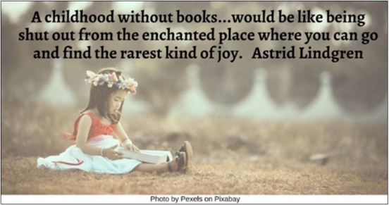



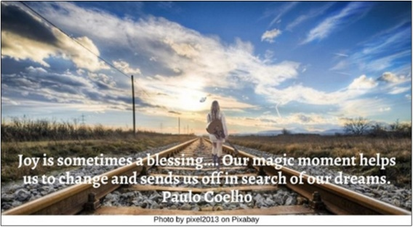







Resources for Children
2.0: Wisdom Stories
The Tapestry of Faith stories are not listed, since those are easily accessible in the curricula listed at 4.0 & 5.0:
Children
2.1: What If Nobody Forgave? by Barbara Marshman (616 words)
In a land far away, a wise old man who knew a great deal about people because he traveled from place to place arrived at a strange village. In this town all the people were carrying what seemed to be great bundles on their backs. They couldn’t look around very well, and they never looked up because of the heavy burdens they carried.
Puzzled, the wise old man finally stopped a young fellow. “My good man, I am a stranger to your land and am fascinated by these large bundles you all carry about but never seem to put down. What is their purpose?”
“Oh, these,” answered the young fellow in a matter-of-fact way. “These are our grudges.”
“My,” said the wise old man, “that’s a lot of grudges to collect at your age!”
“Oh, they’re not all mine. Most of them were passed down in my family.” The young fellow heaved a weary sigh. “See that man over there? I have quite a load of grudges against his family. His great, great grandfather called mine a horse thief when they both wanted to be elected mayor.”
The wise man looked around and shook his head sadly. “You all look so unhappy. Is there no way to get rid of these burdens?”
“We’ve forgotten how,” said the young fellow, shifting his load a little. “You see, at first we were proud of our grudges. Tourists came from miles around. But after a few years, Grudgeville became a dreary place. Nobody came. And we had forgotten how to stop holding our grudges.”
“ If you really want to get rid of those grudges,” said the wise old man, “I think I know five magic words that will do the trick.”
“You do?” asked the fellow hopefully. “That would be a miracle. I’ll go and have the mayor call the people of Grudgeville together.” And off he went, as fast as his grudges would let him.
The mayor lost no time calling the people to the village square. The mayor and the wise old man stood on a platform where they could see all the hunched-over villagers.
When the people had quieted down, the mayor said, “Good people of Grudgeville, a wonderful thing has happened! A very wise stranger has come into our town. He says he can tell us the magic words that will rid us of these grudges we have carried for generations. How many of you would like to be able to straighten up, have your grudges disappear, look at the world in a whole new way? Listen to the wise words of our visitor, then, and do as he tells you.”
“My friends, these are simple words, yet some people find them hard to say,” said the wise stranger. “I think you have the courage to speak them. The trick is that you must say them to each other and truly mean them. The first two words are ‘I’m sorry.’ Can you say them? The other three are ‘I forgive you.’ Can you say that? Now say these words to each other.”
There was a long pause, then a low grumble from the townspeople. First one person, and then another, said the words. Soon they were all saying them to each other—quietly at first and then louder. And then—would you believe it? Just like the wise man predicted, the grudges disappeared! What joy there was in the town. People were heard saying, “Look how those trees have grown!” and “Is that you, Jim? How good to see your face!”
There was dancing in the streets that day, and it wasn’t long before the mayor changed the name of the town to Joytown.
Source: https://www.uua.org/worship/words/reading/5955.shtml

2.2: The Ugly Duckling (1,497 words)
This story is abridged from one published by Hans Christian Anderson in 1844 and translated by H.P. Paull in 1872. (Hans Christian Anderson: Fairy Tales and Stories).
It was lovely summer weather in the country. A duck was on her nest, watching for her young brood to hatch. At length one shell cracked, and then another, and from each egg came a living creature that lifted its head and cried, “Peep, peep!” “Quack, quack,” said the mother, and then they all quacked as well as they could, and looked about them on every side at the large green leaves.
After a time, she asked “Are you all out?” “No, I declare,” she said, “the largest egg lies there still.”
At last the large egg broke, and a young one crept forth crying, “Peep, peep!” It was very large and ugly. The duck stared at it and exclaimed, “It is very large and not at all like the others. I wonder if it is a turkey. We shall soon find it out, however when we go to the water. It must go in, if I have to push it myself.”
On the next day the mother duck took her young brood down to the water, and jumped in with a splash. “Quack, quack,” cried she, and one after another the little ducklings jumped in. They swam about quite prettily with their legs paddling under them as easily as possible, and the ugly duckling was also in the water swimming with them.
“Oh,” said the mother, “that is not a turkey; how well he uses his legs, and how upright he holds himself! He is my own child, and he is not so very ugly after all if you look at him properly. Quack, quack! Come with me now, I will take you into grand society, and introduce you to the farmyard and to the other ducks, but you must keep close to me or you may be trodden upon; and, above all, beware of the cat.”
The ducklings did as they were bid, but the other ducks stared, and said, “What a queer looking object one of them is; we don’t want him here,” and then one flew out and bit him in the neck.
“Let him alone,” said the mother; “he is not doing any harm.”
“Yes, but he is so big and ugly,” said the spiteful duck “and therefore he must be turned out.”
The poor duckling was bitten and pushed and made fun of, not only by the ducks, but by all the poultry. “He is too big,” they all said, and the turkey flew at the duckling, so that the poor little thing did not know where to go, and was quite miserable because he was so ugly and laughed at by the whole farmyard. So, it went on from day to day till it got worse and worse. The poor duckling was driven about by everyone; even his brothers and sisters were unkind to him, and would say, “Ah, you ugly creature, I wish the cat would get you,” and his mother said she wished he had never been born. The ducks pecked him, the chickens beat him, and the girl who fed the poultry kicked him with her feet. So at last he ran away, frightening the little birds in the hedge as he flew over the palings.
“They are afraid of me because I am ugly,” he said. So, he closed his eyes, and flew still farther, until he came out on a large moor, inhabited by wild ducks. Here he remained the whole night, feeling very tired and sorrowful.
In the morning, when the wild ducks rose in the air, they stared at their new comrade. “What sort of a duck are you?” they all said, coming round him.
He bowed to them, and was as polite as he could be, but he did not reply to their question. “You are exceedingly ugly,” said the wild ducks, “you cannot be one of our family.”
The duckling remained alone in the moor, where it loved to swim and dive, but was avoided by all other animals, because of its ugly appearance. Autumn came, and the leaves in the forest turned to orange and gold. Then, as winter approached, the wind caught them as they fell and whirled them in the cold air. The clouds, heavy with hail and snow-flakes, hung low in the sky, and the raven stood on the ferns crying, “Croak, croak.” All this was very sad for the poor little duckling. One evening, just as the sun set amid radiant clouds, there came a large flock of beautiful birds out of the bushes. The duckling had never seen any like them before. They were swans, and they curved their graceful necks, while their soft plumage shown with dazzling whiteness. They uttered a singular cry, as they spread their glorious wings and flew away from those cold regions to warmer countries across the sea. As they mounted higher and higher in the air, the ugly little duckling felt quite a strange sensation as he watched them. He whirled himself in the water like a wheel, stretched out his neck towards them, and uttered a cry so strange that it frightened himself. Could he ever forget those beautiful, happy birds; and when at last they were out of his sight, he dived under the water, and rose again almost beside himself with excitement. He knew not the names of these birds, nor where they had flown, but he felt towards them as he had never felt for any other bird in the world.
The winter grew colder and colder; he was obliged to swim about on the water to keep it from freezing, but every night the space on which he swam became smaller and smaller. At length it froze so hard that the ice in the water crackled as he moved, and the duckling had to paddle with his legs as well as he could, to keep the space from closing up. He became exhausted at last, and lay still and helpless, half frozen fast in the ice. It would be very sad, were I to relate all the misery and privations which the poor little duckling endured during the hard winter; but when it had passed, he found himself lying one morning in a moor, amongst the rushes. He felt the warm sun shining, and heard the lark singing, and saw that all around was beautiful spring. Then the young bird felt that his wings were strong, as he flapped them against his sides, and rose high into the air. They bore him onwards, until he found himself in a large garden, before he well knew how it had happened. The apple-trees were in full blossom, and everything looked beautiful, in the freshness of early spring. From a thicket close by came three beautiful white swans, rustling their feathers, and swimming lightly over the smooth water. The duckling remembered the lovely birds, and felt more strangely unhappy than ever.
“I will fly to those royal birds,” he exclaimed, “and they will kill me, because I am so ugly, and dare to approach them; but it does not matter: better be killed by them than pecked by the ducks, beaten by the hens, pushed about by the maiden who feeds the poultry, or starved with hunger in the winter.”
Then he flew to the water, and swam towards the beautiful swans. The moment they espied the stranger, they rushed to meet him with outstretched wings.
The duckling bent his head down to the surface of the water, and waited for death. But what did he see in the clear stream below? His own image; no longer a dark, gray bird, ugly and disagreeable to look at, but a graceful and beautiful swan. The great swans swam round the new-comer, and stroked his neck with their beaks, as a welcome.
Into the garden presently came some little children, and threw bread and cake into the water.
“See,” cried the youngest, “there is a new one;” and the rest were delighted, and ran to their father and mother, dancing and clapping their hands, and shouting joyously, “There is another swan come; a new one has arrived.”
Then they threw more bread and cake into the water, and said, “The new one is the most beautiful of all; he is so young and pretty.” And the old swans bowed their heads before him.
Then he felt quite ashamed, and hid his head under his wing; for he did not know what to do, he was so happy, and yet not at all proud. He had been persecuted and despised for his ugliness, and now he heard them say he was the most beautiful of all the birds. Even the elder-tree bent down its bows into the water before him, and the sun shone warm and bright. Then he rustled his feathers, curved his slender neck, and cried joyfully, from the depths of his heart, “I never dreamed of such happiness as this, while I was an ugly duckling.”
Source: https://www.uua.org/re/tapestry/multigenerational/hebrewscriptures/workshop7/189184.shtml

2.3: The Lost Son, adapted from Christian scripture (442 words)
There once was a father, who had two sons. The younger son wanted to leave home and travel to distant lands. He asked to have his inheritance. So the father divided his wealth and gave each son his half. The older son stayed at home, continuing to work with his father as before. But the younger son went on a trip. He spent all his money having fun, and one day it was all gone.
When the younger son’s money ran out, he was in a faraway land where he knew no one and could not find a job. He finally found a job taking care of the pigs that belonged to a farmer. Often the younger son had less to eat than the pigs, for he was now very poor.
One day the younger son said to himself, “I should go home. Back at home, my father’s workers have bread enough to spare, but here I am dying of hunger! I will get up and go to my father, and I will say to him, ‘Father, I have wasted your money. I am no longer worthy to be called your son; treat me like one of your workers.’”
So the younger son went home. When his father saw the younger son coming toward him, he rushed to him and kissed him. The younger son said, “Father, I have wasted your money. I am no longer worthy to be your son.” But the father was so happy to see his son he sent his workers to make a great feast to celebrate the homecoming of his younger son. The father smiled and said, “Let us celebrate. My younger son was lost and now is found.”
About this time, the older son came home from his job. He heard the music and dancing at the welcome home feast. He asked a worker what was going on and was told the celebration was for the safe return of his brother.
The older son got mad and refused to come to the party. His father came out and began to plead for the older son to come inside. The older son said, “Father, for years I have been working with you. I never disobeyed you. You never gave me a party so I could celebrate with my friends. And now, my brother has spent his money and come home poor and you are giving him a party. I’m mad.”
The father said to him, “Son, you are always with me and all that is mine is yours. But we have to celebrate and rejoice, because this brother of yours was lost and has been found.”
Source: https://www.uua.org/re/tapestry/children/home/session14/60164.shtml

2.4: The Sword of Wood, A Jewish tale from Afghanistan (1,138 words)
Once, on a summer night in the country Afghanistan, the ruler Shah Abbis changed out of his fancy robes and left his palace dressed as a peasant to enjoy the evening air and to wander through the streets unnoticed. He walked and walked until he reached the poorest section at the edge of the town. He soon heard joyful singing coming from a dimly lit cottage. As he peered in the window, he saw a man sitting at a table. He was eating and singing and giving thanks to God. The shah was astonished to see such a poor man in such good spirits and so he asked if he might come in as a guest.
After accepting food and drink the shah asked the man how he earned his living. I am a poor Jew, he said. I wander the streets and fix shoes, and in this way, I earn enough money to buy all the food I need for one day.
But what will happen to you when you are too old to work? asked the shah.
Oh, I do not have to worry about that, the man said happily. God blesses me day by day, and I know that somehow there will always be enough.
The shah returned to his palace and took off his peasant disguise. He was determined to test the faith of this man. The next day he proclaimed: No one is allowed to fix shoes for pay!
When the Jew went to work, he was astonished to learn of the new law. What is he going to do if he can’t fix shoes and earn money? (Take a few brief suggestions.)
Here’s what he did. He lifted his eyes to heaven (Leader — Raise your arms in the air and look up) and he prayed, God, the Shah has made it against the law for me to fix shoes. But I know you will help me to find a new job. He looked around and saw some people carrying water. He decided that he too would become a water carrier.
The Jew carried water to and from the town well and sold it to people, for the rest of the day. And in that way, he earned just enough money to buy food ... for one day. (Leader — You may wish to start the children at this point repeating the refrain, to buy food for one day, each time you say, he earned just enough money ... )
The shah again disguised himself and returned to the man’s house. He was very surprised to find the man again singing joyfully and eating. How are you? he asked upon entering. I heard of the law and had to see how you had survived the day.
God did not abandon me today, the Jew answered happily. The shah closed one door, but God opened another to take its place. I am now a water carrier.
The shah took his leave again. (Leader — And what do you think he did? After brief answers, continue the story.) He issued another proclamation: no one was to carry water for pay. Again, the Jew wondered how he could earn money if it was against the law to carry water. But again, he prayed and this time he saw that men were going into the forest to cut trees to sell for firewood. So, he decided to cut trees and sell firewood also, and that’s just what he did. And in that way, he earned just enough money... (Leader — Prompt the children to finish your sentence.) ... to buy food for one day.
Again, the shah came in disguise and learned of the man’s continued faith and good fortune. The next day, he issued a command that his soldiers stop all the woodcutters coming from the forests and bring them to the palace to work. He dressed them all as guards and gave them swords. He told them that they would not be paid until the end of the month.
(Leader — What will happen if the Jew is not paid until the end of the month? What do you suppose he should do? After some answers, continue the story.)
The Jew was perplexed indeed, for he had no money for dinner that evening, and it would certainly be difficult to wait a whole month for his pay. But he trusted God. So, he prayed and he prayed for an answer to his problem. How would he be able to buy food tomorrow, if he wouldn’t be paid for a full month?
On the way home from the palace, while examining his sword and sheath, the Jew had a clever idea. He would make a sword out of wood, the same size as the shah’s metal sword that would look just like it. Then he could sell the shah’s sword. So, he made a wooden sword and sold the real one and he had just enough money for food for a month!
The shah, in his peasant disguise again, was much surprised to find the Jew singing and eating that night. When he heard the Jew’s story about the sword, he asked him, “What will you do if the shah finds out what you have done?”
Oh, I do not worry about such things, the Jew replied. Every day my life is filled with blessings from God. I know that somehow everything will come out all right.
The next day the shah ordered all the guards to report to the center of the city where there was to be an execution of a man who had stolen from the royal palace. All the guards came, including the ones who used to be woodcutters, and including the Jew. All the townspeople came to see.
The shah ordered his officer to call the Jew to come forth to cut off the man’s head. Do not ask this of me, the Jew cried. I have never even killed a fly. The officer said that it was the order of the shah and he must obey or risk his own life.
The Jew asked for a few minutes to pray to God. Then he stood up (Leader — Stand up and speak dramatically) in front of all of the townspeople and said out loud, God, you know that I have never killed anyone in my whole life. Please, God, if this man is guilty, let my sword be so sharp as to kill him in a single blow. But if he is not guilty, let my sword turn to wood, as a sign of his innocence. (Leader — Look at the children and ask them to predict what will happen. When they clearly understand what is going to happen with the sword and why, resume telling the story.)
With all eyes on him, the Jew reached for his sword. (Leader — Acts this out) He pulled it out of its sheath, and held it high. The crowd gasped, then clapped and cheered when they saw the wooden sword, for they thought a miracle had taken place.
The shah was delighted when he saw the wisdom of the Jew. He called him near. He told him that he had been the visitor those four preceding nights. And now, he said, I hope that you will come and stay with me in my palace and be my advisor, for I see that you are a man of wisdom and unwavering faith, and I have much to learn from you.
So, the Jew went to live in the palace with the shah. If you went by there in the evenings, you would hear them singing.
Source: https://www.uua.org/re/tapestry/children/tales/session3/story-1

2.5: The Circle of Generosity and Joy by Unknown (417 words)
And old story tells that one day, a countryman knocked hard on a monastery door. When the monk tending the gates opened up, he was given a magnificent bunch of grapes.
“Brother, these are the finest my vineyard has produced. I’ve come to bear them as a gift.”
“Thank you! I will take them to the Abbot immediately, he’ll be delighted with this offering.”
“No! I brought them for you. For whenever I knock on the door, it is you opens it. When I needed help because the crop was destroyed by drought, you gave me a piece of bread and a cup of wine every day.”
The monk held the grapes and spent the entire morning admiring it. And decided to deliver the gift to the Abbot, who had always encouraged him with words of wisdom.
The Abbot was very pleased with the grapes, but he recalled that there was a sick brother in the monastery, and thought: “I’ll give him the grapes. Who knows, they may bring some joy to his life.”
And that is what he did. But the grapes didn’t stay in the sick monk’s room for long, for he reflected: “The cook has looked after me for so long, feeding me only the best meals. I’m sure he will enjoy these.”
The cook was amazed at the beauty of the grapes. So perfect that no one would appreciate them more than the sexton; many at the monastery considered him a holy man, he would be best qualified to value this marvel of nature.
The sexton, in turn, gave the grapes as a gift to the youngest novice, that he might understand that the work of God is in the smallest details of Creation. When the novice received them, he remembered the first time he came to the monastery, and of the person who had opened the gates for him; it was that gesture which allowed him to be among this community of people who knew how to value the wonders of life.
And so, just before nightfall, he took the grapes to the monk at the gates.
“Eat and enjoy them,” he said. “For you spend most of your time alone here, and these grapes will make you very happy.”
The monk understood that the gift had been truly destined for him, and relished each of the grapes, before falling into a pleasant sleep.
Thus, the circle was closed; the circle of happiness and joy, which always shines brightly around generous people.
Source: https://academictips.org/blogs/the-circle-of-joy/

2.6: Two Drops of Oil by Paulo Coelho (482 words)
A certain shopkeeper sent his son to learn about the secret of happiness from the wisest man in the world. The lad wandered through the desert for forty days, and finally came upon a beautiful castle, high atop a mountain. It was there that the wise man lived.
Rather than finding a saintly man, though, our hero, on entering the main room of the castle, saw a hive of activity: tradesmen came and went, people were conversing in the corners, a small orchestra was playing soft music, and there was a table covered with platters of the most delicious food in that part of the world. The wise man conversed with everyone, and the boy had to wait for two hours before it was his turn to be given the man’s attention.
The wise man listened attentively to the boy’s explanation of why he had come, but told him that he didn’t have time just then to explain the secret of happiness. He suggested that the boy look around the palace and return in two hours.
“Meanwhile, I want to ask you to do something,” said the wise man, handing the boy a teaspoon that held two drops of oil. “As you wander around, carry this spoon with you without allowing the oil to spill.”
The boy began climbing and descending the many stairways of the palace, keeping his eyes fixed on the spoon. After two hours, he returned to the room where the wise man was.
“Well,” asked the wise man, “did you see the Persian tapestries that are hanging in my dining hall? Did you see the garden that it took the master gardener ten years to create? Did you notice the beautiful parchments in my library?”
The boy was embarrassed, and confessed that he had observed nothing. His only concern had been not to spill the oil that the wise man had entrusted to him.
“Then go back and observe the marvels of my world,” said the wise man. “You cannot trust a man if you don’t know his house.”
Relieved, the boy picked up the spoon and returned to his exploration of the palace, this time observing all of the works of art on the ceilings and the walls. He saw the gardens, the mountains all around him, the beauty of the flowers, and the taste with which everything had been selected. Upon returning to the wise man, he related in detail everything he had seen.
“But where are the drops of oil I entrusted to you?” asked the wise man.
Looking down at the spoon he held, the boy saw that the oil was gone.
“Well, there is only one piece of advice I can give you,” said the wisest of wise men. “The secret of happiness is to see all the marvels of the world, and never to forget the drops of oil on the spoon.”
Source: The Alchemist by Paulo Coelho

2.7: The Poor? by unknown (224 words)
A very wealthy father took his son on a trip to the country with the purpose of showing his son how poor people live. They spent a couple of days and nights on the farm of what was considered to be a very poor family.
Driving back to the city, the father asked his son, “How was the trip for you?”
“It was great, Dad,” replied the son.
“Did you see how poor people live?” the father asked.
“Oh, yes,” the son said.
“Well, tell me, what did you learn from the trip?”
The son answered:
“I saw that we have one dog and they had four.
We have a pool that reaches to the middle of our garden
and they have a creek that has no end.
We have imported lanterns in our garden
and they have the stars at night.
Our patio reaches to the front yard
and they have the whole horizon.
We have a small piece of land to live on
and they have fields that go beyond our sight.
We have servants who serve us,
but they serve others.
We buy our food, but they grow theirs.
We have walls around our property to protect us;
they have friends to protect them.”
The father was speechless. Then his son added, “Thanks, Dad, for showing me how poor we are?”
Source: https://paulocoelhoblog.com/2019/03/11/how-poor-we-are/

2.8: Mullah Nasruddin and the Search for Joy, adapted (244 words)
One day, Mullah Nasruddin met a man from another town that he had not seen before and began a conversation with him. They talked about the weather, the harvest, and the village market. Before long the man began to confide in Nasruddin. He said that he was a merchant in his home town, but begun traveling in search of something that seemed elusive.
The man lamented, “I am rich, but I am also sad and miserable. I have taken my money and gone traveling in search of joy—but alas, I have yet to find it.”
As the man continued speaking, Nasruddin listened patiently. Then, without warning, Nasruddin grabbed the man’s bag containing his money and belongings and ran off with it. The man was startled, and, with a look of great alarm, chased after him. Since Nasruddin had a head start, he soon disappeared down the road. After a while he stopped. Looking to see if the man was in sight, but he was not. Nasruddin set the bag down in the middle of the road for the merchant to see. He then walked into the forest at the side of the road and hid behind a tree.
When the man finally caught up to where Nasruddin had been, he found the bag, and began dancing in celebration of his good fortune. Looking on, Nasruddin thought to himself, “Joy was right there in the bag all along waiting for him to find it.”
Source: https://www.talesofawesomeness.com/tales-nasruddin-part-1/

3.0: Children’s Books
Joy
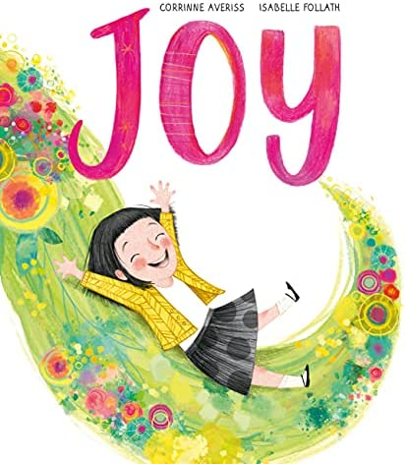
3.1: Joy by Corrinne Averiss (Author) and Isabelle Follath (Illustrator) (2018)
“Fern’s Nanna has not been herself of late. And when Mum remarks that all the joy seems to have gone out of her life, Fern decides to fetch the joy back. With her catching-kit at the ready, she goes to the park and finds joy in all sorts of unusual places. Whooooshh! But Fern soon realizes that joy doesn’t fit in a bag, or a box or a tin! How will she manage to bring some back to Nanna?”
Video Link: https://www.youtube.com/watch?v=Ni_lxS6Xsy8&t=65s (4:18)

3.2: Now by Antoinette Portis (2017)

“Joy is something we experience in the present moment, and the book, Now is a perfect way to attune your minds to that. Read it before you head outdoors, or bring it with you, and it will inspire you to find your favorite sources of joy—because they are the ones right in front of you, right now.”
Video Link: https://www.youtube.com/watch?v=JP_Xnl-h0To (3:36)

3.3: Everywhere, Wonder by Matthew Swanson, author and Robbi Behr, illustrator (2017)
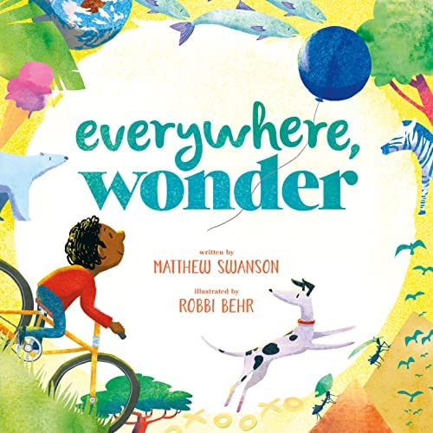
“This incredibly touching book just might be the perfect primer for joy hunting. It reminds us that we each have our own, joyful stories made up of the marvelous things we notice each day. Best of all, the book celebrates both the grand wonders we can only imagine and the wonders that hide right in front of us.”
“Readers are taken on a stunning journey into the imagination of a young boy―who explores everything from the pyramids of Egypt to a dusty footprint on the moon―and then back out again to the wonderful world right in front of him. From a lost balloon to an endless road, there are stories to discover, to dream about, and to share.
“Everywhere, Wonder explores the wonder in the world, while encouraging young minds to discover the extraordinary in the ordinary, and creatively share their stories with others.” Wonder is a feeling that can lead to awakening.
Video Link: https://www.youtube.com/watch?v=rgJNFOGyd0s (5:48)

3.4: Sky Color by Peter Reynolds (2012)
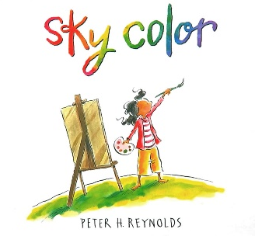
“Marisol loves to paint. So when her teacher asks her to help make a mural for the school library, she can’t wait to begin! But how can Marisol make a sky without blue paint? After gazing out the bus window and watching from her porch as day turns into night, she closes her eyes and starts to dream. . .
“Color is a universal source of joy, and we so often forget that nature gave our world the sky—a giant backdrop full of ever-changing color. It’s easy to spark joy if you make it a habit to notice and admire our ever-changing, always inspiring sky.”
Video Link: https://www.youtube.com/watch?v=fAx2mZwO6bc (3:20)

3.5: Joy: A Celebration of Mindfulness by Katie Wilson (2020)
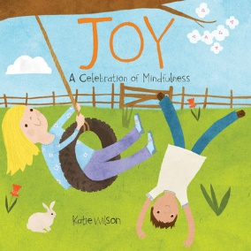
“This book takes a playful approach to finding joy in our daily lives and features the many ways children can experience happiness. From finding joy in stories to finding joy in quiet time, readers will recognize the moments and actions that put a smile on their face each day.”
Video Link: https://www.youtube.com/watch?v=SITAVBWnJ3Y (1:30)

3.6: The Joyful Book by Todd Parr (2020)
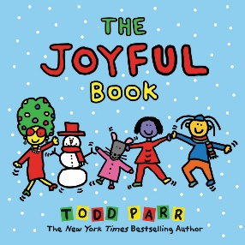
“Whether it's celebrating a holiday, sharing a meal, or learning new things, The Joyful Book inspires readers of all ages to spread the joy near and far, to loved ones and friends. With his renowned blend of warmth, humor, and heart, Todd Parr encourages young readers to look for all the ways that joy surrounds them.”
Video Link: https://www.youtube.com/watch?v=7p4Laz26vvY (3:59)

3.7: The Little Book of Joy by Dalai Lama & Desmond Tutu (Authors) and Rafael López (Illustrator) 2022
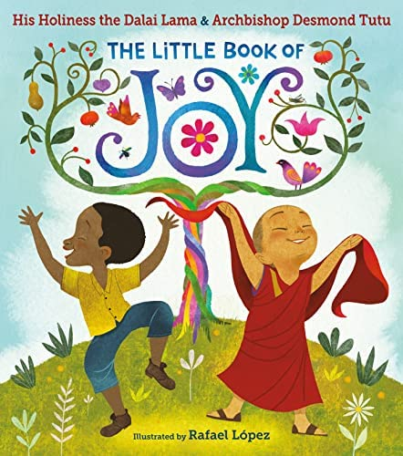
“In their only collaboration for children, His Holiness the Dalai Lama and Archbishop Desmond Tutu use their childhood stories to show young people how to find joy even in hard times and why sharing joy with others makes it grow. The two spiritual masters tell a simple story, vibrantly brought to life by bestselling illustrator Rafael López, of how every child has joy inside them, even when it sometimes hides, and how we can find it, keep it close, and grow it by sharing it with the world.”
Video Link: https://www.youtube.com/watch?v=_ohfSOQIoV4 (5:51)

3.8: The Joy in You by Cat Deeley (Author) and Rosie Butcher (Illustrator) (2020)
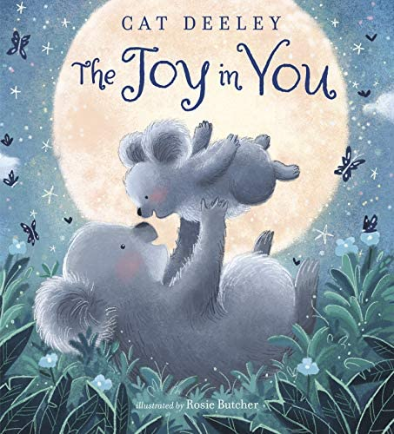
“‘Dream big, as big as the night sky full of stars. When you discover the things you love, you’ll find true joy.”
“Journey through a magical world where readers will find endless opportunities to be themselves and find freedom in expression, no matter where they are or who they’re with.
“Feel uplifted and hopeful when you connect with life's most joyful moments….”
Video Link: https://www.youtube.com/watch?v=xBAz57bxJUo (4:31) (story begins at 1:35)

3.9: Little Joy by Nadine Brun-Cosme (Author) and Marion Cocklico (Illustrator) 2020
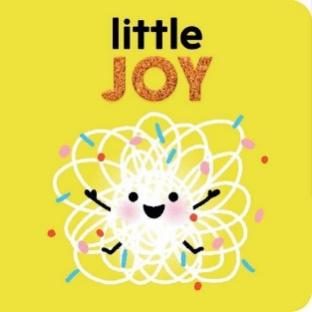
“In this adorable story full of cheer, Little One feels oh-so-happy that...poof! She becomes Little Joy.
“‘When Little One wakes up,
She opens one eye and then the other.
As the sun shines on her cheek,
Little One’s heart beats really fast.’
“…Little Joy discovers what makes her happy!”
Video Link: https://www.youtube.com/watch?v=WEAGdKuUPGc (1:03)

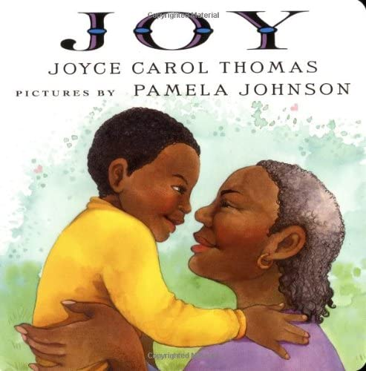
3.10: Joy! by Joyce Carol Thomas (Author) and Pamela Johnson (Illustrator) (2001)
“Throughout the year, a grandmother expresses her unconditional love for her grandson.”
Video Link: https://www.youtube.com/watch?v=ZGRqZxVAdPY (2:59)

3.11: Festival of Colors by Surishtha Sehgal & Kabir Sehgal (Authors) and Vashti Harrison (Illustrator) 2018
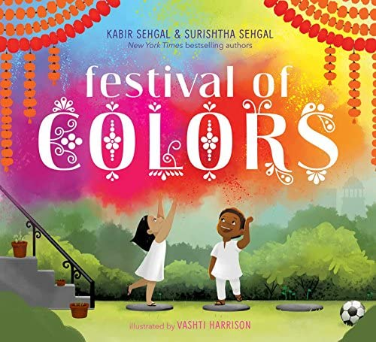
“The Indian festival of Holi is celebrated with tremendous joy and happiness, and is centered around both color and close connection with community. This delightful book shares the essence of this beautiful and most joyful holiday….”
Video Link: https://www.youtube.com/watch?v=vufwJI6x7A8 (3:06)

Happiness
3.12: Have You Filled a Bucket Today? A Guide to Daily Happiness for Kids by Carol McCloud, author and David Messing, illustrator (2015)
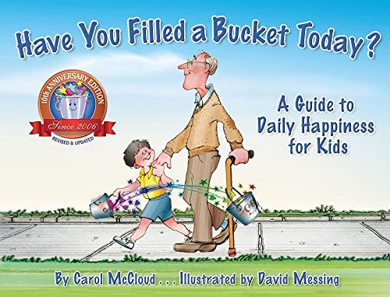
“While using a simple metaphor of a bucket and a dipper, author Carol McCloud illustrates that when we choose to be kind, we not only fill the buckets of those around us, but also fill our OWN bucket! Conversely, when we choose to say or do mean things, we are dipping into buckets. All day long, we are either filling up or dipping into each other’s buckets by what we say and what we do. When you’re a bucket filler, you make the world a better place to be!”
Video Link: https://www.youtube.com/watch?v=3EuemNAo6XE (5:24)

3.13: My Heart Fills With Happiness by Monique Gray Smith (Author) and Julie Flett (Illustrator) (2016)


“The sun on your face. The smell of warm bannock baking in the oven. Holding the hand of someone you love. What fills your heart with happiness? This beautiful board book, with illustrations from celebrated artist Julie Flett, serves as a reminder for little ones and adults alike to reflect on and cherish the moments in life that bring us joy.

“…Monique Gray Smith wrote My Heart Fills with Happiness to support the wellness of Indigenous children and families, and to encourage young children to reflect on what makes them happy.”

Video Clip: https://www.youtube.com/watch?v=tO77a3-6lbo (2:38)

3.14: Pass it On by Sophy Henn (2017)

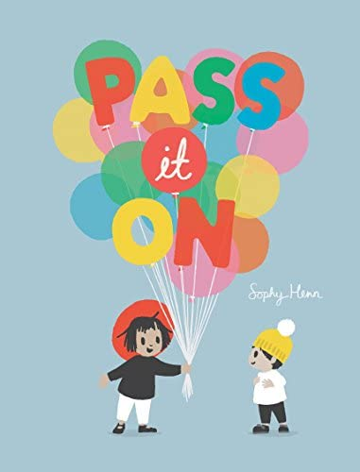
‘When you see something terrific, smile a smile and pass it on! If you chance upon a chuckle, hee hee hee and pass it on. Should you spot a thing of wonder, jump for joy and pass it on!’

“So, begins Sophy Henn’s ode to the excitement of sharing happiness with others. With a refrain that begs to be uttered before every turn of the page, children will eagerly read alongside their parents as they discover how wonderful—and fun—it is to share the good things in life. After all, if you spread happiness to others, even on a gray, rainy day, when you least expect it, like a bolt out of the blue, a smile or a chuckle might be passed right back to you.”

Video Link: https://www.youtube.com/watch?v=HG_HsTBa_-Q (1:58)

3.15: Augustus and His Smile by Catherine Rayner (2007)

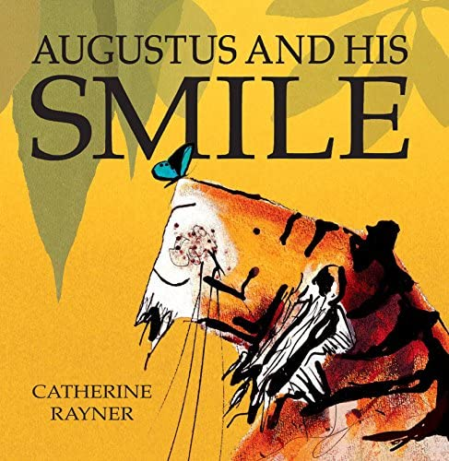
“Augustus the tiger was sad. He had lost his smile. So, he did a HUGE tigery stretch, and set off to find it. Stunning illustrations celebrate the beauty of the world and the simple happiness it brings to us. An imaginative book for children who love to explore the world around them.”

Video Link: https://www.youtube.com/watch?v=qFDFB36fWwk (3:01)

3.16: You Are My Happy by Hoda Kotb, author and Suzie Mason, illustrator (2019)

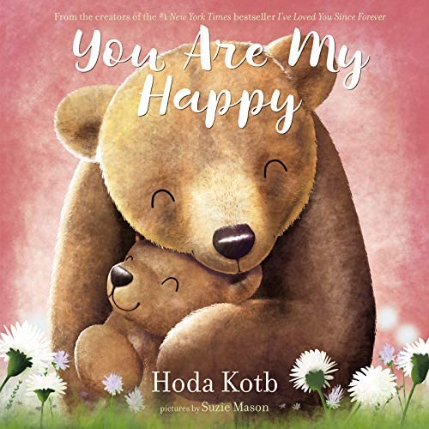
“As mama bear and her cub cuddle together before closing their eyes for a good night’s sleep, they reflect on the everyday wonders of life that make them happy.”
Video Link: https://www.youtube.com/watch?v=J9Z11nBowJM (4:01)

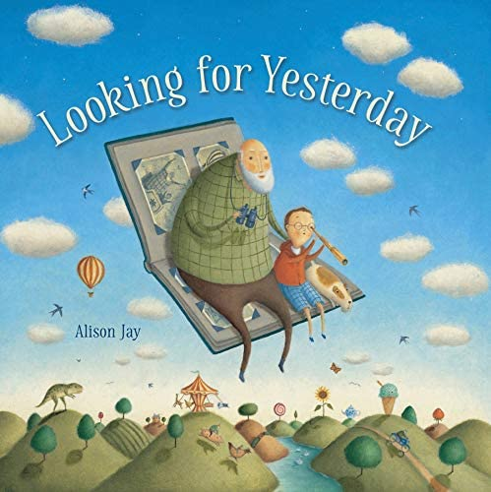
3.17: Looking for Yesterday by Alison Jay (2019)

If yesterday was the best day ever, wouldn’t it be great to find a way to repeat it? A whimsical tale about happiness with sure appeal for science-minded kids — and wise grandparents — everywhere.

What could beat yesterday’s perfect day at the fair? Maybe nothing, one boy thinks, and he wishes he could go back and do it again. So he puts all his scientific knowledge to work, from stars to time machines to wormholes (is it possible he could find one in his garden?). He thinks that maybe Grandad could help him. But Grandad, in sharing some memories from his own past, reminds him that every new day brings the chance of a new adventure.

Video Link: https://www.youtube.com/watch?v=fTQd0OSv72E (2:28)

3.18: Happiness Doesn’t Come from Headstands by Tamara Levitt (2017)

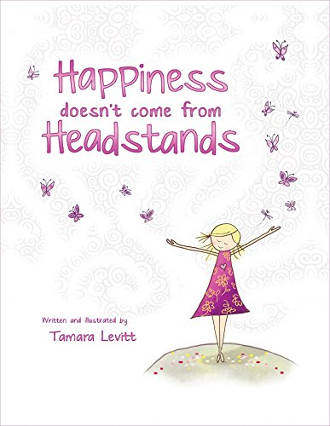
“‘Leela loves to do yoga. She could do all sorts of poses, but there was one pose she couldn’t do. Every time Leela tried to do a headstand…KERPLUNK!’ his book explores the themes of acceptance, resilience, and self-compassion and offers the message that just because we may experience a failure does not mean that we are a failure. …[This is] a story about a girl who tries her best, but still falls down. Through the process she learns that happiness is not determined by external achievement. Through accepting our limitations and celebrating our efforts, even in the face of failure, peace can be found.”

Video Link: https://www.youtube.com/watch?v=Yd9-AoDu-P4 (5:30)

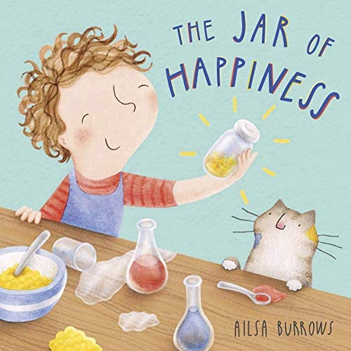
3.19: The Jar of Happiness by Ailsa Burrows (2016)

“Is there a recipe for happiness? Meg certainly thinks so. She collects all the necessary ingredients in a jar, which she uses to cheer up her friends and family when they’re feeling low. But what happens when her special jar mysteriously disappears? Will Meg feel sad forever more, or will she find other ways to be happy?”
Video Link: https://www.youtube.com/watch?v=ilb5-PetjcE (2:33)

3.20: The Big Little Thing by Beatrice Alemagna (2019)

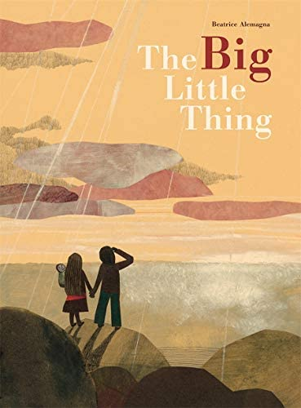
“It unexpectedly arrived. It brushed

passed someone in the street. It weaves

its way in and out of people on the street.

It catches people completely unawares.

But what is this It? They call It . . . happiness!”
Audio Link: https://www.podomatic.com/podcasts/davidkrutprojects/episodes/2019-11-26T00_37_42-08_00

4.0: Curriculum & Theme-Based Classroom Activities for Children

from Tapestry of Faith
4.1: Chalice Children: A Program about Our Unitarian Universalist Community for Preschoolers
4.1.1: Session 10: Helping Others
Link: https://www.uua.org/re/tapestry/children/chalicechildren/session10
Helping others can give the joy, and there is also joy in helping.
“Participants will:
- Understand that caring for others is an important part of being a Unitarian Universalist
- Express their own caring by creating cards for people who are lonely or sick
- Connect the story with their caring feelings.”
4.1.2: Session 20: Rainbows
Link: https://www.uua.org/re/tapestry/children/chalicechildren/session20
Nature can be a source of joy, and rainbows often elicit awe and joy.
“Participants will:
- Experience a shared sense of wonder
- Learn that their congregation is a place where questions and wondering are encouraged
- Connect the story they read in this session with their experiences of rainbows.”
4.1.3: Session 25: Teddy Bear Month — Friendship
Link: https://www.uua.org/re/tapestry/children/chalicechildren/session25
Making friends, especially for children, is often a cause for joy.
Participants will:
- Learn how to make the Chalice Children group feel like a friendly place
- Experience caring and sharing as a way of affirming themselves and others
- Practice the skills involved in making friends with others
- Feel a sense of competence by teaching the bears the Chalice Children songs and games.
4.1.4: Session 26: Teddy Bear Month — Sick!
Link: https://www.uua.org/re/tapestry/children/chalicechildren/session26
Caring can bring joy to others, and can sometimes lead to joy for the caregiver.
“Participants will:
- Feel empowered to care for others
- Practice the skills of helping someone who is sick to feel better.”
4.1.5: Session 28: Teddy Bear Party
Link: https://www.uua.org/re/tapestry/children/chalicechildren/session28
Attending a party can be a source of joy.
“Participants will:
- Experience the sense of community and belonging they have developed in Chalice Children and appreciate their own role in creating it
- Acknowledge the friends they have met
- Feel connected to their UU identity and the congregation.”

4.2: Creating Home: A Program on Developing a Sense of Home Grounded in Faith for Grades K-1
4.2.1: Session 8: Hare's Gifts
Link: https://www.uua.org/re/tapestry/children/home/session8
Being part of a community can bring joy, as can participating in a communtity.
“Participants will:
- Experience cooperation in playing group games
- Learn about community as a gift after hearing the story, "Hare's Gifts"
- Make music individually and together as a community activity”
4.2.2: Session 10: Tango
Link: https://www.uua.org/re/tapestry/children/home/session10
Being part of a family can be a source of joy.
Participants will:
- Play a dancing game in which they choose partners
- Honor diverse families by making badges recognizing family members and their roles
- Through a story about Tango and her family, learn about family diversity
- Identify some of the elements that bond families
- Discuss how we enter faith families
- Affirm their sense of belonging by telling stories about entering and belonging in their faith family …
- Learn that people fill more than one role in a family.
For a story for this session see 3.2, A Penguin Story, which is about Tango. You can also watch a video reading if the boo, And Tango makes three at https://www.youtube.com/watch?v=bGZHD4SKmQU (6:36)
4.2.3: Session 11: Bless This Meal
Link: http://www.uua.org/re/tapestry/children/home/session11
The story, The Best Meal, illustrates how joy can emerge within a family based on the love and cooperation through which a meal is created.
“Participants will:
- Create table tents for family and faith homes
- Hear a story about the joys of sharing not just food, but goodwill and community at a meal
- Learn blessings and graces to use at their family and faith homes
- Name ways we commonly bless
- Practice saying grace and enjoying community at mealtime”
4.2.4: Session 14: Comings and Goings
Link: https://www.uua.org/re/tapestry/children/home/session14
The story, the Lost (i.e., Prodigal) Son, is a source of joy for the father alongside the jealously and anger of the faithful son
“Participants will:
- Listen and respond to the central story, ‘The Lost Son’
- Experience the story through dramatic play with stick puppets
- Apply the theme of coming and going to their own lives in a rhythmic chant
- Explore homecomings in their own families
- Help participants understand the role of the family home to instruct us and then send us out into the world, always welcoming us on the return
- Prepare participants to understand growing up as a way of making meaning and finding purpose that may need to happen while being away from home
- Experience losing and finding something in a game”

4.3: Wonderful Welcome: A Program for Children Grades K-1
“Welcome. Welcome in love. Welcome in friendship. Welcome in faith. The Wonderful Welcome curriculum engages and challenges leaders and children alike to explore how and why we are willing to welcome others into our lives. We welcome not only strangers, but family, our peers, our neighbors and even entities that are not people such as our animal friends and nature itself.
“How do we welcome? We welcome by sharing intangible gifts, those positive qualities which we all have inside us such as kindness, love, invitation, covenant and empathy. In this program, children learn to articulate and express a variety of intangible gifts, empowering them to share these gifts with others.
The gifts outlined in these 16 sessions can all be sources of joy.
Session 1: The Gift Of Love
Session 2: The Gift Of Covenant
Session 3: The Gift Of Forgiveness
Session 4: The Gift Of Kindness
Session 5: The Gift Of Invitation
Session 6: The Gift Of Friends
Session 7: The Gift Of Helping
Session 8: The Gift Of Families
Session 9: The Gift of Mutual Caring
Session 10: The Gift Of Protection
Session 11: The Gift Of Stewardship
Session 12: The Gift Of Acceptance
Session 13: The Gift Of Learning Together
Session 14: The Gift Of Spirit
Session 15: The Gift Of Ourselves
Session 16: The Gift Of Community

4.4: Love Surrounds Us: A Program on the UU Principles and Beloved Community for Grades K-1
4.4.1: Session 1: Love Surrounds Us
Link: https://www.uua.org/re/tapestry/children/lovesurrounds/session1
Love is a profound source of joy.
“Participants will:
- Learn the theme song ‘Love Surrounds Me’
- Connect love to themselves and others
- Discover the strength of the word ‘love.’”
4.4.2: Session 4: Forgiveness
Link: https://www.uua.org/re/tapestry/children/lovesurrounds/session4
Extending forgiveness often brings joy to the person who has been forgiven.
“Participants will:
- Explore how love and forgiveness connect us, through a sewing project
- Experience a story of forgiveness drawn from Genesis 43:16-46:7 in Hebrew scripture
- Practice using the words of forgiveness ‘you are forgiven’ and ‘I forgive you,’ in a game.”
4.4.3: Session 6: Acceptance
Link: https://www.uua.org/re/tapestry/children/lovesurrounds/session6
The story in this session, Odd Velvet, is a wonderful example of how unexpected friendships can develop over time, and bring joy.
“This session will:
- Introduce the Unitarian Universalist idea that all people are accepted in our congregations (third Principle)
- Affirm the call to welcome all into in our congregations
- Introduce the Buddhist concept of loving kindness.”
Odd Velvet by Mary E. Whitcomb, author and Tara Calahan King, illustrator (1998)
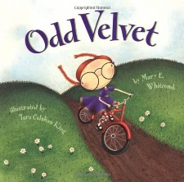
“Velvet is odd. Instead of dolls that talk and cry, Velvet brings a milkweed pod for show and tell. She wins the class art contest using only an eight-pack of crayons. She likes to collect rocks. Even her name is strange-Velvet! But as the school year unfolds, the things Velvet does and the things that Velvet says slowly begin to make sense. And, in the end, Velvet's classmates discover that being different is what makes Velvet so much fun.”
Video Link: https://www.youtube.com/watch?v=Jg-Fzg6mmkQ (4:59)
4.4.4: Session 15: Caring for the Earth
Link: https://www.uua.org/re/tapestry/children/lovesurrounds/session15
Caring for the earth can be a source of joy, especially as we experience the majesty and mystery of the planet that gives us life.
“Participants will:
- Learn that Unitarian Universalists believe we must show love to the earth because it is our only home
- Learn that each and every human, animal, and plant depends on this one small planet for life
- Understand how taking care with our environment benefits everyone and every living thing.”

4.5: World of Wonder: A Program on the Seven Principles of Unitarian Universalism for Grades K-1
4.5.1: Session 10: Joy in Nature: Animal Play
Link: https://www.uua.org/re/tapestry/children/wonder/session10
Play, for children, is a primary source of joy.
“This session will:
- Introduce the spiritual dimension and physical benefits of play
- Foster empathy for animals particular to their playfulness and a sense of connection with all creatures in the web of life that play
- Build community in the group through playing together
- Empower participants as leaders in the group
- Draw on direct observation of the natural world as one of the Sources of Unitarian Universalism
- Reinforce the seventh Unitarian Universalist Principle, ‘respect for the interdependent web of all existence of which we are a part.’”
4.5.2: Session 11: Kindness in Nature
Link: https://www.uua.org/re/tapestry/children/wonder/session11
Empathy and connection can lead to joy.
“This session will:
- Demonstrate altruism in non-human parts of the web of life
- Foster empathy and a sense of connection with other living beings
- Encourage emotional intelligence, the ability to recognize their own and others’ feelings and to respond helpfully when someone is distressed
- Empower participants as leaders in the group
- Reinforce the seventh Unitarian Universalist Principle, ‘respect for the interdependent web of all existence of which we are a part.’”

4.6: Moral Tales: A Program on Making Choices for Grades 2-3
4.6.1: Session 4: In Another's Shoes
Link: https://www.uua.org/re/tapestry/children/tales/session4
Doing acts of goodness can be a source of joy, and, sometimes, mutual joy.
“This session will:
- Give participants an opportunity to share acts of goodness that they have done (or witnessed)
- Provide a story and active experiences that demonstrate the meaning of the word ‘Empathy’ and how empathy feels
- Teach that an important part of acting out of goodness is to look at things from other perspectives besides one's own
- Help participants learn to identify, respect and value the perspectives and experiences of others which differ from their own
- Strengthen participants' connection to and sense of responsibility to their faith community”
4.6.2: Session 5: Forgiveness
Link: https://www.uua.org/re/tapestry/children/tales/session5
Extending forgiveness often brings joy to the person who has been forgiven.
“Participants will:
- Participate in the Gems of Goodness exercise
- Hear a story illustrating the act of forgiveness
- Explore the feelings and actions of the characters in the story by retelling key parts of the story
- Make personal connections to the feelings and actions of the characters in the story by using a story theater
- Experience letting go of a held resentment through an exercise with sand
- Share a personal story of an act of kindness done to them through an exercise with clay.”
4.6.3: Session 7: Seeing Others with Awe
Link: https://www.uua.org/re/tapestry/children/tales/session7
Truly seeing others with awe, especially their inherent worth and dignity, can bring joy.
“This session will:
- Explore the implications of the first Unitarian Universalist principle, the inherent worth and dignity of every person
- Introduce the idea of ‘awe’ and the notion that all living beings are worthy of awe
- Acquaint participants further with one another as they learn to value their similarities and differences
- Demonstrate that seeing others with awe leads to interactions that are characterized by justice and goodness
- Help participants experience themselves as valued members of the Moral Tales community
- Guide participants to identify their own gifts and talents, as well as those of their peers.”
4.6.4: Link: https://www.uua.org/re/tapestry/children/tales/session8
The act of the Good Samaritan illustrating the Golden Rule can be a source of joy for the stranger who receives such compassion.
“Participants will:
- Participate in the "Gems of Goodness" exercise
- Hear a story illustrating an act of compassion for a stranger
- Participate in a cooperative game in which they think about how they would like to be treated, and have an opportunity to treat others with care
- Imagine how they might apply the Golden Rule to a variety of scenarios
- Visualize and portray the concept that all people are our neighbors
- Optional: Planning a faith in action projects in which they will practice reaching out with kindness to neighbors near and far.
4.6.5: Session 9: Generosity: Give and Ye Shall Receive
Link: https://www.uua.org/re/tapestry/children/tales/session9
The idea that by giving you will receive is called the Generosity Paradox, which can also be the Joy Paradox. Generosity can change the giver, especially as he or she experiences joy in giving.
“Participants will:
- Learn an example of generosity from a true story about an Islamic man who gave away caravans of food to hungry villagers during a drought
- Consider the benefits of generosity from the points of view of both the giver and the receiver
- Explore the gifts of time, talent, and mentorship they can offer other children by sharing their home-made modeling dough with a younger group.”
4.6.6: Session 13: Justice for All
Link: https://www.uua.org/re/tapestry/children/tales/session13
Working for justice can bring joy to those who are oppressed.
“This session will:
- Make participants aware of the inequitable distribution of wealth around the world
- Build participants’ empathy for people who are treated unfairly
- Begin to empower participants to take action when they experience or witness injustice
- Teach participants to be allies for people who are oppressed, suffering or being treated unfairly
- Engage participants in experiences that promote the second and fourth Unitarian Universalist Principles: justice, equity and compassion in human relations, and the goal of world community with peace, liberty, and justice for all.”

4.7: Faithful Journeys: A Program about Pilgrimages of Faith in Action for Grades 2-3
4.7.1: Session 2: Unconditional Love, a Gift from Our Universalist Heritage
Link: https://www.uua.org/re/tapestry/children/journeys/session2
Unconditional love is ofte a source of joy.
“Participants will:
- Learn about a childhood experience of Universalist preacher Hosea Ballou, that exemplifies key Universalist beliefs about universal salvation and love
- Experience their congregation as a place where they are loved and give unconditional love to others, despite imperfections, as they identify and affirm some of their own strengths and interests
- Name ways they might act that respond to the signpost ‘Respect Everyone’
- Name ways they have translated faith into action by participating in the Faithful Footprints exercise
- Take responsibility for creating a safe learning environment by reviewing and signing the Faithful Journeys group covenant.”
4.7.2: Session 5: Finding Balance
Link: https://www.uua.org/re/tapestry/children/journeys/session5
Choosing to share resources to help others who have less can lead to joy to the receiver and the giver.
“Participants will:
- Develop an understanding of equity; learn that there is such a thing as having more than you need and such a thing as not having enough
- Learn how contemporary Unitarian Universalists, including children, have chosen to share resources to help others who have less
- Become empowered as agents of change who can identify practices of material excess and explore choices of voluntary simplicity
- Experience balance and centeredness as physical qualities and learn about them as qualities of lifestyle
- Generate and follow up on ideas to reduce, reuse, and recycle”
4.7.3: Session 7: Create Magic, Change the World
Link: https://www.uua.org/re/tapestry/children/journeys/session7
Our third Unitarian Universalist Principle, which begins with “acceptance of one another” can be a source of mutual joy.
“This session will:
- Teach that we express our third Unitarian Universalist Principle, acceptance of one another and encouragement to spiritual growth, in our congregations when we engage in spiritual practices that include and promote active involvement in the world
- Strengthen Unitarian Universalist identity through connection with our sixth Source, spiritual teachings of Earth-centered traditions that celebrate the sacred circle of life and instruct us to live in harmony with the rhythms of nature
- Include a story about a child who models courage as she faces her fear and speaks publicly at a peace rally
- Demonstrate the idea that faithful intention and focusing our energy can be tools for practicing ‘magic’ for the benefit of the world
- Teach children how their own actions can and do express their faith — their ideas of right and wrong, their values and their beliefs.”

4.8: Love Will Guide Us: A Program for Grades 2-3 that Applies the Wisdom of the Six Sources to the Big Questions
“In this program, participants learn to seek guidance in life through the lens of our Unitarian Universalist Sources, with an emphasis on love. Together we ask questions such as, ‘Where did we come from?’ ‘What is our relationship to the Earth and other creatures?’ ‘How can we respond with love, even in bad situations?’ ‘What happens when you die?’ Sessions apply wisdom from our Sources to help participants answer these questions. Participants will learn that asking questions is valued in Unitarian Universalism, even as they begin to shape their own answers.”
The 12 sessions listed below, which get at the big questions, illustrate how love can elicit joy.
Session 1: Love Is Like a Seed
Session 2: Awesome Love
Session 5: We Are Loved, Flaws and All
Session 6: Love Is Eternal
Session 7: Give Love
Session 8: Love Is Accepting
Session 10: Love for All Creatures
Session 11: Love and Gratitude
Session 12: From Anger to Kindness
Session 13: Responding with Love
Session 15: Love in Action
Session 16: Love Is the Golden Rule

4.9: Signs of Our Faith: A Program about Being UU Every Day for Grades 2-3
4.9.1: Session 6: Signs of Caring
Link: https://www.uua.org/re/tapestry/children/signs/session6
The sharing of joys and concerns can elicit joy, which can be even more profound given the reality of concerns, especially sorrow.
“Participants will:
- Understand a Sharing of Joys and Concerns ritual as a symbol of our UU belief that we are interconnected and must care for one another
- Share joys and concerns in community
- Identify themselves as loving individuals, capable of providing care and worthy of receiving care, and understand that caring actions can be a sign of their UU faith
- Demonstrate caring, by making “caring candles” for the congregation.”
4.9.2: Session 8: Memorial Rituals
Link: https://www.uua.org/re/tapestry/children/signs/session8
When we celebrate a loved one’s life in death, we often lift up the memories that brought us joy.
“Participants will:
- Create a memorial ritual
- Understand that death is a part of life
- Understand that while Unitarian Universalist memorial rituals vary, all share the goals of helping us (1) acknowledge our loss and (2) celebrate the loved one’s life—indeed, all life—as sacred
- Discover rituals and signs their UU congregation uses when someone dies
- Explore the concept of a person living on after their physical death in other people’s remembered experiences of them, through a story of Jesus.”

4.10: Toolbox of Faith: A Program That Helps Children Discover the Uses of Faith, Grades 4-5
4.10.1: Session 6: Expression (Paintbrush)
Link: https://www.uua.org/re/tapestry/children/toolbox/session6
Personal expression, especially artistic expression in response to our first source, can elicit joy in the act of creating or viewing an artistic work.
This session will:
- Help deepen participants' Unitarian Universalist identity, ethical discernment, and understanding of Unitarian Universalist faith through reflection and discussion
- Teach that Unitarian Universalism is a faith that will help you express your inner voice and your inner thoughts
- Introduce the Unitarian Universalist Principles that affirm and promote the inherent worth and dignity of every person and acceptance of one another and encouragement to spiritual growth
- Demonstrate that personal expression is one way Unitarian Universalism affirms the direct experience of that transcending mystery and wonder, affirmed in all cultures, which moves us to a renewal of the spirit and an openness to the forces which create and uphold life
4.10.2: Session 9: Spirit Of Life (Canteen)
Link: https://www.uua.org/re/tapestry/children/toolbox/session9
Reenacting the Water Communion and singing the Spirit of Life can both, because of their deep meaning, elicit joy.
“Participants will:
- Explore the qualities of water through discussion and hands-on experiences
- Make a symbolic connection between the fluidity and pervasiveness of water and the fluidity and pervasiveness of the Spirit of Life
- Develop a personal sense of the Spirit of Life, by reaching into our Jewish and Christian heritage, our Unitarian Universalist love of reason, and our willingness to seek the divine in everything
- Reenact the water communion through visualization and emphasize how all water is connected, just as all things are connected by the Spirit of Life
- Learn the Unitarian Universalist hymn, Spirit of Life
- Focus on one of the sources of the Unitarian Universalist Living Tradition, ‘the direct experience of that transcending mystery and wonder, affirmed in all cultures, which moves us to a renewal of the spirit and an openness to the forces which create and uphold life’”
4.10.3: Session 12: Humor (Sandpaper)
Link: https://www.uua.org/re/tapestry/children/toolbox/session12
Humor is a pathway to laughter, and laughter is a pathway to joy.
“Participants will:
- Experience the qualities of sandpaper as it smoothes the rough edges of wood
- Connect sandpaper, a tool for smoothing the rough edges of wood, with humor, a quality of our Unitarian Universalist faith which can smooth the rough edges of life
- Hear a story that uses humor to teach
- Enjoy their own humor and experience the joy of sharing humor together through play, parody songs, and making their own clownish designs with face paint
- Reflect on humor as a religious tool of our faith”
4.10.4: Session 13: Love (Gloves)
Link: https://www.uua.org/re/tapestry/children/toolbox/session13
Experiencing compassion, both as a giver and as a receiver, can elicit joy.
“Participants will:
- Learn about the universality of human compassion
- Explore the strength of love
- Bodily practice and experience the strength of compassionate dialogue with one another
- Articulate ways that they have experienced compassion, both as a giver and as a receiver.”
4.10.5: Session 15: Atonement (Level)
Link: https://www.uua.org/re/tapestry/children/toolbox/session15
The act of atonement can lead to reconciliation, and then, to joy.
“Participants will:
- Learn the vocabulary words, ‘atonement’ and ‘reconciliation’
- Understand how the tool, a level, symbolizes the restoration of balance that comes with ‘at-one-ment’ or atonement
- Hear a true story illustrating how some Unitarian Universalists made a mistake and, later, a new generation of Unitarian Universalists tried to restore balance, to atone
- Play games that illustrate concepts related to atonement, including disarray and unity and the difficulties of assigning blame
- Express a form of reconciling prayer in the process of handling and baking bread
- Discuss their feelings on the value of restoring balance, at-one-ment, by making an apology.”

4.11: Windows and Mirrors: A Program about Diversity for Grades 4-5
4.11.1: Session 4: Building A Community Of Forgiveness
Link: https://www.uua.org/re/tapestry/children/windows/session4
Extending forgiveness often brings joy to the person who has been forgiven.
“Participants will:
- Practice the skills of offering forgiveness to those who have broken a covenant
- Connect their own thoughts and experiences with a story about a group of Buddhist students’ experience of covenant and forgiveness
- Articulate ways they express and consider ways to enforce the group covenant
- Understand how practicing forgiveness helps heal hurt feelings
- Commit to practicing at home forgiveness skills learned during the session.”
4.11.2: Session 9: Lean On Me
Link: https://www.uua.org/re/tapestry/children/windows/session9
Empathy can be a gateway to joy as we deeply experience the lives of others.
“Participants will:
- Hear a story from the Muslim faith about how the support of Mohamed’s wife, Khadija, was crucial to his acceptance of his calling
- Experience and process a trust walk—a physical exploration of giving and receiving support
- Develop empathy by imagining what it must have been like for Khadija, the wife of Mohamed, to be his first supporter.”
4.11.3: Service Is The Rent We Pay For Living
Link: https://www.uua.org/re/tapestry/children/windows/session10
Our gratitude for people involved in service jobs and all of the helping professions can be a source of joy, as it was during the height of the pandemic. Also recall Tagore’s realization: “I slept and dreamt that life was joy. I awoke and saw that life was service. I acted and behold, service was joy,” and imagine how those providing service may also experience joy.
“Participants will
- Identify and appreciate the service jobs people do that ensure the health and welfare of the larger society
- Explore difficulties and challenges inherent in public service, including the potential complexity of determining one’s duty or responsibility
- Hear a story about Arjuna and reflect on a conflict about military service
- Create cards conveying good wishes and appreciation to recovering military personnel at a veterans’ hospital.”

4.12: Love Connects Us: A Program on Living in Unitarian Universalist Covenant for Grades 4-5

4.12.1: Session 2: A Heritage of Love

Link: https://www.uua.org/re/tapestry/children/loveconnects/session2

The heritage of love bestowed by the Universalist part of our tradition encourages us to love and accept love, as well as the joy that can go with it.
This session will:
- Through a story about Judith Sargent Murray, introduce the Universalist heritage of love which comes to us from our Universalist roots and lift up an early feminist writer from our faith tradition
- Demonstrate how an emphasis on love creates an environment of acceptance and fosters cooperation
- Provide experiences where participants act to fulfill our third Principle, “encouragement to spiritual growth in our congregations.”
- Involve participants in creating a symbol of the heritage of love which ties us together by making a friendship bracelet
4.12.2: Session 3: Love is the Spirit of this Church
Link: https://www.uua.org/re/tapestry/children/loveconnects/session3
As the story about the old woman and young girl illustrates, giving love away and receiving love can lead to both joy and sorrow.
“Participants will:
- Experience and respond to a story about how love becomes more powerful when it is given away
- Experience activities which require working together to accomplish an objective
- Understand how sharing joys and concerns together is one way people in a beloved community can support one another in good times and bad
- Reflect on how we all have a role in creating our beloved communities.”
4.12.3: Session 4: Love Your Neighbor as Yourself
Link: https://www.uua.org/re/tapestry/children/loveconnects/session4
The Golden Rule can be a gateway to joy. The story of the two runners at the Special Olympics who helped a third runner resulted in “everyone in the stands …standing and cheering, some with tears rushing down their faces.” Those were tears of joy.
“Participants will:
- Reflect on and discuss a story that demonstrates both the ethic of reciprocity and a kind of radical hospitality
- Experience, in games and activities, how affirming one another deepens our connections and builds our sense of community
- Reflect on how radical hospitality enriches our communities and each of us as individuals
- Explore their individual responsibility and practical ways to offer radical hospitality to others.”
4.12.4: Session 5: Meeting People Where They Live
Link: https://www.uua.org/re/tapestry/children/loveconnects/session5
Being of service to others can both bring joy and cause the one doing the act of service to experience joy. Recall Tagore’s realization: “I slept and dreamt that life was joy. I awoke and saw that life was service. I acted and behold, service was joy.”
“Participants will:
- Give examples of how they and their congregation embody a faith covenant through acts of service
- Learn about Joseph Tuckerman, Unitarian minister and pioneer in the field of social work
- Experience the theme of connections to Tuckerman’s work with waterfront families by tying sailor knots
- Experience Tuckerman’s method of asking families what service they needed, by interviewing one another
- Understand ‘service’ as an important Unitarian Universalist value.”
4.12.5: Session 9: Kindness is the Key
Link: https://www.uua.org/re/tapestry/children/loveconnects/session9
Kindness can elicit joy for both the receiver and the giver.
Participants will:
- “Give examples of how they embody their faith through acts of peace-building
- Learn the true story of The Christmas Truce, about opposing soldiers who chose to create a brief time of peace on a World War I battlefield
- Embody the tied together theme of the curriculum in a multi-legged race
- Consider their full range of options for action in conflict situations
- Practice creative conflict-resolution skills by acting out different solutions to a conflict.”

4.13: Sing to the Power: A Social Justice Program for Children Grades 4-5
4.13.1: Session 8: The Power of Listening
Link: https://www.uua.org/re/tapestry/children/sing/session8
Deep listening can evoke joy in others as they realize that they are being heard.
“Participants will:
- Hear the story of Unitarian Universalist minister Don Robinson, who created Beacon House Community Ministries for children and youth, in partnership with members of the Washington, DC community in which it is located
- Practice deep attention and listening through an exercise in which the group counts to ten
- Experience the power of listening and presence, by listening to a partner rant about a pet peeve
- Create ‘all ears’ hats as a reminder to listen actively and deeply.”

4.14: Riddle and Mystery: A Program on the Big Questions for Grade 6
4.14.1: Session 6: Thinking of Death
Link: https://www.uua.org/re/tapestry/children/riddle/session6
When we celebrate a loved one’s life in death, we often lift up the memories that brought us joy.
“Participants will:
- Compare and contrast death beliefs of various religions
- Learn the perspective of a contemporary Unitarian Universalist theologian
- Consider the concept that we live on, after death, through our actions in life and in the love and memories of others
- Reflect on their own ideas about death
- Plan and/or experience a ritual to recognize the deaths of individuals in their congregation, family or community.”

4.15: Amazing Grace: A Program about Exploring Right and Wrong for Grade 6
4.15.1: Session 15: Saving the World
Link: https://www.uua.org/re/tapestry/children/grace/session15
Random acts of kindness can elicit mutual joy.
“This session will:
- Explore the power of the individual
- Consider the nature of universal love
- Plan and practice random acts of kindness”

4.16: Heeding the Call: A Program on Justice-making for Junior High School Youth
4.16.1: Workshop 10: The Call for Joy
Link: https://www.uua.org/re/tapestry/youth/call/workshop10
This workshop explores and celebrates joy.
“Participants will:
- See joy as an important quality in justice making and imagine ways to feel more joyful and spread joy to others
- Identify and appreciate what brings them personal joy
- Identify humor as a tool for diffusing conflict and healing from trauma
- Understand the importance of joy and laughter for children and youth around the world
- Have fun!”
4.16.2: Workshop 11: The Call for Forgiveness
Link: https://www.uua.org/re/tapestry/youth/call/workshop11
Extending forgiveness often brings joy to the person who has been forgiven.
“This workshop will:
- Identify forgiveness as a quality needed to bring about a more just world
- Demonstrate that forgiveness is connected to the inherent worth and dignity of every person (first Principle)
- Explore forgiveness as a challenging and rewarding activity
- Examine forgiveness on different levels, both large and small.”

4.17: Miracles, Wide Age Span
4.17.1: Session 2: The Miracle of Close Attention
Link: https://www.uua.org/re/tapestry/multigenerational/miracles/session-2
Paying attention to nature and everyday life can often reveal the miraculous and elicit joy.
“This session will:
- Encourage participants to recognize the miraculous in nature and everyday life
- Teach focused attention as a spiritual practice that helps us find miracles around us
- Cultivate skills of close attention
- Introduce poet May Sarton, a like-minded friend of Unitarian Universalism whose personal faith was grounded in direct experiences of awe and wonder.”

4.18: Circle of Trees: A Multigenerational Program about Nourishing Deep Connections with Nature
4.18.1: Workshop 4: Trees: Sanctuary for the Spirit
Link: https://www.uua.org/re/tapestry/multigenerational/trees/workshop4
Becoming aware of our profound interdependence with all life can lead to joy.
“This workshop will:
- Encourage personal expressions of gratitude for trees
- Explore the poetic and artistic inspiration that trees and nature provide
- Reinforce the concept of interdependence as expressed in the seventh Unitarian Universalist Principle, ‘Respect for the interdependent web of all existence of which we are a part’
- Affirm that stewardship of the earth is an explicit act of faith.”
In place of the recommended poems about trees for use as the story, we suggest the piece written by Herman Hesse and published in 1920. You can find it at https://www.faena.com/aleph/what-trees-teach-us-about-life-and-ownership-by-hermann-hesse

Resources for Youth
5.0: Curriculum & Theme-Based Classroom Activities for Youth
Tapestry of Faith
Youth
5.1: A Place of Wholeness: A Program for Youth Exploring Their Own Unitarian Universalist Faith Journeys
5.1.1: Workshop 6: Nurturing the Spirit
Link: https://www.uua.org/re/tapestry/youth/wholeness/workshop6
The story of the creation of the Spirit of Life is moving. The hymn is a source of joy to many Unitarian Universalists.
“Participants will:
- Discuss what spirituality means
- Share spiritual practices
- Explore the differences between spirituality and theology or doctrine
- Reflect on everyday activities that can be spiritual practices
- Optional: Experience the spiritual practices of members of the congregation.”

5.2: Virtue Ethics: An Ethical Development Program for High School Youth
5.2.1: Workshop 9: Generosity
Link: https://www.uua.org/re/tapestry/youth/virtueethics/workshop9
The idea that by giving you will receive is called the Generosity Paradox, which can also be the Joy Paradox. Generosity can change the giver, especially as he or she experiences joy in giving.
“This workshop will:
- Examine the meaning of generosity
- Highlight resources, other than financial, that youth can give generously
- Explore situations where generosity is used or called for
- Guide youth to identify themselves as generous people.”
5.2.2: Workshop 11: Forgiveness
Link: https://www.uua.org/re/tapestry/youth/virtueethics/workshop11
Extending forgiveness often brings joy to the person who has been forgiven.
“Participants will:
- Explore the meaning of ‘forgiveness’
- Discuss a dilemma that calls for forgiveness
- Examine their own history of forgiveness and commit to the future practice of forgiveness in their lives.”

6.0: Readings
6.1: Joy by David Whyte (240 words)
Joy can be made by practiced, hard-won achievement as much as by an unlooked for, passing act of grace arrived out of nowhere; joy is a measure of our relationship to death and our living with death, joy is the act of giving ourselves away before we need to or are asked to, joy is practiced generosity. If joy is a deep form of love, it is also the raw engagement with the passing seasonality of existence, the fleeting presence of those we love understood as gift, going in and out of our lives, faces, voices, memory, aromas of the first spring day or a wood fire in winter, the last breath of a dying parent as they create a rare, raw, beautiful frontier between loving presence and a new and blossoming absence.
To feel a full and untrammeled joy is to have become fully generous; to allow ourselves to be joyful is to have walked through the doorway of fear, the dropping away of the anxious worried self felt like a thankful death itself, a disappearance, a giving away, overheard in the laughter of friendship, the vulnerability of happiness felt suddenly as a strength, a solace and a source, the claiming of our place in the living conversation, the sheer privilege of being in the presence of a mountain, a sky or a well-loved familiar face—I was here and you were here and together we made a world.
Source: Consolations: The Solace, Nourishment and Underlying Meaning of Everyday Words by David Whyte

6.2: What Can I Do? An Alphabet of Ideas for Anxious Times by Rev. Martha Peck (85 words)
Act as you wish the world to become
Believe
Create beauty
Defend those who are in danger
Experience nature
Feed people
Give of yourself
Hope, then help it happen
Inspire imitation
Join with others [in joy]
Know your strengths
Listen, Learn, Love
Make music
Name the good
Organize for change
Play
Quiet your mind
Respect differences
Savor life
Take risks
Use less of the earth’s resources
Voice your vision
Welcome strangers
X Cross out cruelty
Yield your privilege
ZZZ… Sleep well, because God is awake.
Source: https://www.chestervtuu.org/past-sermons/2016/12/12/making-a-place-for-joy-kevin-carson

6.3: The Secret of Happiness by Alfred North Whitehead (167 words)
The secret of happiness lies in knowing this: that we live by the law of expenditure. We find the greatest joy not in getting, but in expressing what we are. There are tides in the ocean of life, and what comes in depends on what goes out. The currents flow inward only where there is an outlet. Nature does not give to those who will not spend; her gifts are merely loaned to those who will not use them. Empty your lungs and breathe. Run, climb, work, and laugh; the more you give out, the more you shall receive. Be exhausted, and you shall be fed. (Our) gladness is not in taking and holding, but in doing, the striving, the building, the living. It is a higher joy to teach than to be taught. It is good to get justice, but better to do it; fun to have things, but more fun to make them. The happy person is the one who lives the life of love....
Source: https://www.uua.org/worship/words/sermon/183421.shtml

6.4: Joy Is of Many Kinds by Howard Turman (223 words)
Joy is of many kinds. Sometimes it comes silently, opening all closed doors and making itself at home in the desolate heart. It has no forerunner save itself; it brings its own welcome and salutation. Sometimes joy is a compound of many elements: a touch of sadness, a whimper of pain, a harsh word tenderly held until all its arrogance dies, the casting of the eye into the face that understands, the clasp of a hand that holds, then releases, a murmur of tenderness where no word is spoken, the distilled moment or remembrance of day, a night, an hour, lived beyond the sweep of the daily round—joy is often compounded of many things.
There is the joy that is given. There are those who have in themselves the gift of Joy. It has no relation to merit or demerit. It is not a quality they have wrested from the vicissitudes of life. Such people have not fought and won a hard battle; they have made no conquest. To them Joy is given as a precious ingredient in life. Wherever they go, they give birth to Joy in others – they are the heavenly troubadours, earthbound, who spread their music all around and who sing their song without words and without sounds. To be touched by them is to be blessed [of God].
Source: The Mood of Christmas & Other Celebrations by Howard Turman

6.5: An Accidental Classic by Greg Forster (178 words)
Did you know that Joy to the World was not written as a Christmas carol? In its original form, it had nothing to do with Christmas. It wasn’t even written to be a song.
Isaac Watts was one of the great hymn writers in church history, and I guess nothing shows that better than the fact that he wrote one of his most famous hymns by accident. In 1719, Watts published a book of poems in which each poem was based on a psalm. But rather than just translate the original Old Testament texts, he adjusted them to refer more explicitly to the work of Jesus as it had been revealed in the New Testament.
One of those poems was an adaptation of Psalm 98. Watts interpreted this psalm as a celebration of Jesus’s role as King of both his church and the whole world. More than a century later, the second half of this poem was slightly adapted and set to music to give us what has become one of the most famous of all Christmas carols.
Source: Joy for the World: How Christianity Lost Its Cultural Influence and Can Begin Rebuilding It by Greg Forster.

6.6: Mindful by Mary Oliver (115 words)
Everyday
I see or hear
something
that more or less

kills me
with delight,
that leaves me like a needle

in the haystack
of light.
It was what I was born for—
to look, to listen,

to lose myself
inside this soft world—
to instruct myself
over and over

in joy,
and acclamation
Nor am I talking
about the exceptional,

the fearful, the dreadful,
the very extravagant—
but of the ordinary,
the common, the very drab,

the daily presentations.
Oh, good scholar,
I say to myself,
how can you help

but grow wise
with such teachings as these—
the untrimmable light

of the world,
the ocean's shine,
the prayers that are made
out of grass?
Source: https://www.atimeofmyown.com/uploads/5/1/1/6/51161337/mindful_mary_oliver.pdf

6.7: Joy is Hard by Rev. Joe Cherry (116 words)
Joy is hard.
Joy requires us to feel safe enough,
to be safe enough, to open to vulnerability.
To feel joy, you must be brave.
Joy walks into a room after the space has been cleared
Cleared of shame,
Cleared of doubt
Cleared of self-recrimination.
Joy is hard.
Joy is hard
and joy is worth the hard work of preparation.
Preparing oneself and setting down all the defenses
all the shoulds and could'ves,
all the should not haves and might haves.
Joy is worth the work.
You are worth the work.
You can start small:
the simple pleasure of your favorite tea,
the grand freedom of a full belly laugh.
Invite Joy to be your companion.
Source: https://uuffm.org/wp-content/uploads/Sandscript/DECEMBER-2021-SANDSCRIPT.pdf

6.8: Joy Sundays by Edward Hays (263 words)
The goal of every religious seeker should be to be giddy since in Old English it once meant, “possessed by a god or spirit.” Being possessed by the Spirit wasn't such a desirable state, since those caught in the grip of God were considered to be insane, simpleminded, or religious fanatics. In time the word changed from connoting foolish to being incapable of serious thinking. And you can be assured that if you strive to be constantly cheerful, even in the most dismal of situations, you will be judged as a shallow thinker or at best uninformed. After all, who can be always joyful if they live in the “real” world?
The Church, preoccupied with the need to be taken seriously by the world, is constantly cautious of appearing as foolish or silly, and so has wisely limited celebrating rejoicing to only two Sundays out of the year. One comes in the middle of Advent, and in the Old Latin is called Gaudete, “Rejoice” Sunday. The second one comes in the middle of Lent and was called Laetare Sunday, also Latin for rejoice. To live in joy, which Paul said was the will of God for us, seems to require a change in the Church's liturgical calendar. To remind the faithful of their duty to remain joyful while confronting all of the terrible sufferings plaguing the human family — wars, violence, famine, and global poverty — the Church should have at least one Gaudete-Laerare Sunday a month! Such monthly Joy Sundays would reinforce that God's will be done on earth as it is in heaven!
Source: https://www.spiritualityandpractice.com/book-reviews/excerpts/view/16653/chasing-joy

6.9: A Giddy Joy, except from Idiot Psalms, a Psalm of Issak by Scott Cairns (26 words)
Make me awaken daily with a willingness
to roll out readily, accompanied
by a grateful smirk, a giddy joy,
the idiots’ undying expectation
despite the evidence.
Source: https://www.poetryfoundation.org/poetrymagazine/poems/51994/idiot-psalms

6.10: Joy in the Hard Stuff by Carolyn Hobbs (266 words)
…Doing the things we love, no matter how much we love them, brings only a fleeting joy. Try as we may to cram every weekend, every vacation, every free moment with the things we love, we still have to return to the rest of our lives: We still have work to do, groceries to buy, bills to pay, and the car to keep running. We still have to wake up four or five times in the night to nurse the infant and get up early to taxi the older kids to school, then get ourselves to work on time. …
We can't expect to find joy in all this hard stuff. Or can we? I'm here to tell you that we can. In fact, if we only expect to find joy while doing what we really love, we end up spending about 90 percent of our lives joyless. And, as you will soon find out, we are the ones who limit our joy. That's not only a lousy deal, it's not at all the way it's supposed to be.
I want to introduce you to a broader, more expanded version of joy. I want to reacquaint you with the unlimited joy that lives deep in your core. Not that over-the-top ecstatic joy we feel after dancing, skiing or doing what we love all day (though it can be) but the softer, subtler joy that can flood our awareness with a sense of inner peace and well-being, no matter what is happening around us. The ever-present inner joy that allows us to take everything much less seriously.
Source: https://www.spiritualityandpractice.com/book-reviews/excerpts/view/14669

6.11: Life's Most Important Skill by Matthieu Ricard (264 words)
Is happiness a skill that, once acquired, endures through the ups and downs of life? There are a thousand ways of thinking about happiness….
By happiness I mean …a deep sense of flourishing that arises from an exceptionally healthy mind. This is not a mere pleasurable feeling, a fleeting emotion, or a mood, but an optimal state of being. Happiness is also a way of interpreting the world….
…Someone …walking through a serene wilderness, has no particular expectations beyond the simple act of walking. She simply is, here and now, free and open.
For just a few moments, thoughts of the past are suppressed, the mind is not burdened with plans for the future, and the present moment is liberated from all mental constructs. This moment of respite, from which all sense of emotional urgency has vanished, is experienced as one of profound peace.
…But this experience is just a passing glimpse brought on by a particular set of circumstances. We call it a magic moment, a state of grace. And yet the difference between these flashes of happiness seized on the fly and the immutable peacefulness of the sage, for instance, is as great as that between the tiny section of sky seen through the eye of a needle and the limitless expanses of outer space. The two conditions differ in dimension, duration, and depth.
Even so, we can learn something from these fleeting moments, these lulls in our ceaseless struggles; they can give us a sense of what true plenitude might be and help us to recognize the conditions that favor it.
Source: https://www.spiritualityandpractice.com/book-reviews/excerpts/view/15581

6.12: Create Spaces of Joy by Angela Williams Gorrell (190 words)
Like other powerful emotions, joy can be difficult for us, even terrifying, as researcher Brené Brown has discussed, because it requires vulnerability and courage. The moment we experience joy, we might wonder when we will lose it, or we might immediately anticipate that disappointment or disaster are sure to follow.
We also do not share our joy boldly lest we be seen as overly excited or too expressive. To display joy fully requires being “too demonstrative,” “too passionate” — or so we might imagine. We may be anxious about being “too much.”
Joy, like other emotions, longs to be shared though. Expressing joy, as with other challenging emotions, requires support.
Not only do we need permission to be honest about emotions like sadness, anger, and fear, we need permission to be joy-filled. And we need this permission from other people and ourselves. We can give one another and ourselves permission to experience joy in many ways.
One is to create spaces of joy.
Like preparing for joy (ladders against fences), we can organize spaces that are meant to invite and cultivate joy — spaces that suggest joy is both anticipated and welcomed.”
Source: https://www.spiritualityandpractice.com/book-reviews/excerpts/view/28674

6.13: Laughing Prayer by Edward Hays (264 words)
The Japanese have a centuries old ritual called Waraiko they use to greet a new year and to celebrate birthdays. The ritual consists of giving three hearty belly laughs! The first robust laugh is of gratitude for the previous year just ended. The second hearty laugh is in gratitude for being given a new year of life to enjoy. The third is a really full-bodied belly laugh, since it is to blow the dust off your mind, heart, and soul. Dust? The dust of habit and routine that slowly accumulates like all dust, causing the soul to lose the luster of its youthful vitality.
Instead of restricting the Waraiko ritual only to New Year's Eves and birthdays, consider the possibilities of using this ritual of three hearty laughs as your morning prayer. At the beginning of a new day, your first prayer laugh would be in gratitude for all the gifts of yesterday and a good night's sleep. Your second laugh could be for the wondrous gift of a new day of life overflowing with opportunities to enjoy it fully. The third and boisterous laugh would be to blow the dust off your soul so it and your heart can glisten like the rising sun.
… When you pray, go in your room, close the door and do so in secret. While sage advice for any prayer, it's especially true for Waraiko prayer. If you faithfully observe his prayer rule of praying in secret and someone actually does observe you at your Waraiko morning prayer, don't be concerned if they think you are giddy!
Source: https://www.spiritualityandpractice.com/book-reviews/excerpts/view/16653/chasing-joy

6.14: Inviting Joy by Rev. Joe Cherry (160 words)
Is our searching for the comfortable and familiar actually decreasing our capacity for joy?
…Joy is also more possible if we do our best to work against what is called
Negativity Bias, which is defined as our tendency not only to register negative
stimuli more readily, but also to dwell on these events.
Inviting Joy would seem to be, then, an intentional act. To be open to new ideas and new possibilities, to take in new information, to step out of our emotional safety and into a wider field, and to also notice, and then let go of negative stimuli.
…I encourage you to let go of perfection, to embrace what is good, rather than to wish for what is better. To not only demonstrate kindness to others, but to accept it graciously when it is offered to you.
This, of course, cannot guarantee joy, because nothing can. But to do the opposite will surely make joy harder to find.
Source: https://uuffm.org/wp-content/uploads/Sandscript/DECEMBER-2021-SANDSCRIPT.pdf

6.15: Altruistic Joy by Chade-Meng Tan (267 words)
… Altruistic joy is usually defined as joy derived from the success and good fortune of others, but it can also refer in general to joy that is free of selfishness, resentment, jealousy, and envy. It is the direct opposite of the German word schadenfreude, which is pleasure derived from the misfortunes of others.
Altruistic joy can be delicious because other people's good fortune tends to be quite visible, so if only I'm capable of rejoicing at other people's good fortune, I can rejoice a lot.
…In my experience, altruistic joy is much harder to cultivate than loving-kindness and compassion. Some meditation masters appear to have arrived at the same conclusion. The revered German-born Buddhist scholar-monk Nyanaponika Thera said, for example, that “it is relatively easier for man to feel compassion [or loving-kindness] in situations which demand them, than to cherish a spontaneous feeling of shared joy, outside a narrow circle of one's family and friends.”
…There is a subset of altruistic joy that is easy and uplifting, and that is rejoicing in the inner goodness and altruistic behavior of others. It is easy and uplifting because we are hardwired to be awed and inspired. Bring to mind somebody who you know is very kind and generous, and you feel awed, inspired, and uplifted. Rejoice! When you read of a woman who spends all her days volunteering at the local hospital to bring joy to cancer patients, you feel awed, inspired, and uplifted. Rejoice! When you hear of a man running into a burning building to save a total stranger, you feel awed, inspired, and uplifted. Rejoice!
Source: https://www.spiritualityandpractice.com/book-reviews/excerpts/view/28088

6.16: The Spiral of Joy by Brother David Steindl-Rast (264 words)
I recognize, I acknowledge, I am grateful; in French these three concepts are expressed by one term: “Je suis reconnaissant.”
I recognize the special quality of this joy: It is a joy freely granted to me as a favor. I acknowledge my dependence, freely accepting as a gift what only another, as other, can freely give to me. And I am grateful, allowing my emotions fully to taste and to express the joy I have received, and thus I make it flow back to its source by returning thanks. You see that the whole person is involved when we give thanks from our hearts. The heart is that center in which the human person is one: The intellect recognizes the gift as gift; the will acknowledges my dependence; the emotions, like a sounding board, give fullness to the melody of this experience.
…Expression of thanks is a [...] spiral in which the giver receives thanksgiving, and so becomes receiver, and the joy of giving and receiving rises higher and higher. The mother bends down to her child in his crib and hands him a rattle. The baby recognizes the gift and returns the mother’s smile.
…Notice that the upward movement of our spiral signifies not only that the joy has grown stronger. Rather we have passed on to something entirely new. A passage has taken place. A passage from multiplicity to unity: we start out with giver, gift and receiver, and we arrive at the embrace of thanks expressed and thanks accepted. Who can distinguish giver and receiver in the final kiss of gratitude?
Source: https://www.awakin.org/v2/read/view.php?tid=2503

6.17: Living Joyfully by Sanaya Roman (234 words)
If you choose, decide that you will begin living joyfully, regardless of what is happening in your life or the world around you. To start living joyfully, pause for a moment, take a breath in, and connect with your innermost self, simply by having the intention to do so. It is fine if it feels like you are using your imagination or if the connection only lasts for a few seconds. Your true, innermost being is always with you. This is who you are deep within. This self is joyful!
Imagine that you are tapping into the joy that has always been within you. You have had many moments of joy in your life, and you are now deciding to create and experience more moments of joy. Ask your innermost self to flood your entire personality, your whole being, with its joy. As it does, open to receive and experience the joy that is your birthright; that is the essence of who you are.
Picture how you will feel as you allow yourself to experience joy throughout the day in everything you do and with all the people you encounter. Sense how your joyful energy lifts everyone around you. Your joy is a gift to the world; your joy brings joy to others. Imagine how you will feel at the end of the day or week as you allow yourself to live more joyfully.
Source: https://www.spiritualityandpractice.com/book-reviews/excerpts/view/21175

6.18: The Last Word? A Smile! by Thomas A. Forsthoefel (265 words)
…What exactly do smiles have to do with holiness? Everything. Something known and knowing occurs in a smile. The smile contains, perhaps, everything we need as humans to negotiate the convoluted paths of our lives. The smile addresses very local realities, but it also intimates and transmits something broader, something bolder, something utterly free. We live in a world shaken by tumult, disorder, and abject confusion. …To what do we turn for reassurance? Where is some consolation amid the heartache of personal and social chaos? …Our own suffering and that which we witness everywhere bear down upon us, and we feel our world — and perhaps our hearts — closing. And then we see a smile of someone special. It could be the smile of one's beloved, a smile that somehow holds everything in great tenderness. Or it may be a smile of a child, a smile that reminds us of beauty and innocence in the world. Or it may be the smile of ordinary persons who have lived life in extraordinary ways. These people seem to have won something for their efforts, a peace that, far from being disingenuous in the face of the world's troubles, often appears to penetrate much deeper than those struggles. Their smiles seem somehow to possess extra value, owing to the host of choices made in their lives, all of which become a cogent word, an exquisite soulsong [of joy] …. Their smiles are congruent with a particular vision of reality, one in which love and kindness, and not aggression or despair, speak the last word, no matter the extent of sorrow and suffering.
Source: https://www.spiritualityandpractice.com/book-reviews/excerpts/view/16324

6.19: Enigma by Janice M. Jones (57 words)
Maybe the reason we can't capture joy
is that it comes in pieces
a forgiveness granted
an accident avoided
a friendship deepened
a gratitude spoken
a talent discovered
a natural wonder witnessed
a difficult concept mastered
a goal attained
a love recovered
that must be put together like a puzzle
and appreciated like a beautiful picture,
unfolding.
Source: https://www.spiritualityandpractice.com/book-reviews/excerpts/view/19204

6.20: The Joy of Being by Eckhart Tolle (232 words)
Unhappiness or negativity is a disease on our planet. What pollution is on the outer level is negativity on the inner. It is everywhere, not just in places where people don't have enough, but even more so where they have more than enough. Is that surprising? No. The affluent world is even more deeply identified with form, more lost in content, more trapped in ego.
People believe themselves to be dependent on what happens for their happiness, that is to say, dependent on form. They don't realize that what happens is the most unstable thing in the universe. It changes constantly. They look upon the present moment as either marred by something that has happened and shouldn't have or as deficient because of something that has not happened but should have. And so they miss the deeper perfection that is inherent in life itself, a perfection that is always already here, that lies beyond what is happening or not happening, beyond form. Accept the present moment and find the perfection that is deeper than any form and untouched by time.
The joy of Being, which is the only true happiness, cannot come to you through any form, possession, achievement, person, or event — through anything that happens. That joy cannot come to you — ever. It emanates from the formless dimension within you, from consciousness itself and thus is one with who you are.
Source: https://www.spiritualityandpractice.com/book-reviews/excerpts/view/19587

6.21: Smiling by Susyn Reeve (244 words)
Smiling is a simple, magical gesture that expresses peace and happiness. It is a gift that we can easily give. When we give it away to others, we clearly get the benefit of the energy of the smile moving through us. …It takes seventeen muscles to smile and forty-three to frown. So, it involves much less effort than a scowl, and in the words of a Ziggy cartoon, “A SMILE is a facelift that's in everyone's price range!”
I have noticed the power of a smile to change my experience in the moment. I have recently returned to practicing yoga. Usually once or twice during our class, the instructor, Ani Kalfayan, will say, 'Turn up the corners of your mouth. Yoga is meant to be joyful.' I follow her instructions, and immediately I experience a lightness of being. As I do this, my eyes are usually closed, and I feel the power of my smile embracing me. …I am also aware that I have another smile. It's the sourpuss smile, and behind this smile a judge is holding court, doling out judgments, and communicating to others what I may be thinking I am hiding.
…Get to know your smiles and use your smiles to share your love and be a gateway to moving your experience from sad to glad. Play and smile and imagine all the peace and happiness we would experience each and every day if we let a smile lead our way.
Source: https://www.spiritualityandpractice.com/book-reviews/excerpts/view/14147

6.22: Sharing Joy by Angela Perkey (120 words)
Finding joy in the midst of everyday life and sharing it with others is crucial to leading a happy life. I will never forget driving down Hogan Road in Nashville each week when I was growing up. Without fail, on just about every sunny day, a man who was mentally handicapped would sit in a lawn chair in his front yard and wave to everyone who drove past. His smile was brilliant, and it almost never failed to make me smile as well. He always seemed so excited to see you drive by. Despite his disability, he had the capability to make others happy. He shared his joy for life with others. And all it took was a big-hearted wave.
Source: https://www.spiritualityandpractice.com/book-reviews/excerpts/view/19835

7.0: Popular Music
7.1: Over The Rainbow & What A Wonderful World Medley by Israel Kamakawiwo'ole (5:05)
Video Link: https://www.youtube.com/watch?v=Z26BvHOD_sg
7.2: Happy by Pharrell Williams (4:06)
Video Link: https://www.youtube.com/watch?v=y6Sxv-sUYtM
7.3: Three Little Birds (Bob Marley) feat. Baaba Maal by Playing For Change (4:427
Video Link: https://www.youtube.com/watch?v=eqqWfsIxbPo
7.4: Don't Worry, Be Happy by Bobby McFerrin (3:51
Video Link: https://www.youtube.com/watch?v=d-diB65scQU
7.5: Don't Worry Be Happy (Bobby McFerrin) | Playing For Change (3:59)
Video Link: https://www.youtube.com/watch?v=uWXUWepSak4
7.6: I Still Haven’t Found What I’m Looking For by Playing For Change (5:35)
Video Link: https://www.youtube.com/watch?v=WJsWWTpagUQ
7.7: Celebration (Kool and The Gang) by Playing For Change (3:52)
Video Link: https://www.youtube.com/watch?v=8Lu41LulQos
7.8: What a Wonderful World (Louis Armstrong) | Playing For Change (3:40)
Video Link: https://www.youtube.com/watch?v=ddLd0QRf7Vg
7.9: We Found Love by Lindsey Stirling wit Alisha Popat and Mackenzie Madsen (4:26)
Video Link: https://www.youtube.com/watch?v=0g9poWKKpbU
7.10: Joy Comes Back by Ruthie Foster (4:36)
Video Link: https://www.youtube.com/watch?v=ZXp4BfMtQ-c
7.11: It's a Beautiful Morning by The Rascals (2:36)
Video Link: https://www.youtube.com/watch?v=64uikGn-q3k
7.12: Joy to the World by Three Dog Night (3:10)
Video Link: https://www.youtube.com/watch?v=M9uoq9gfeL0
7.13: Happiness by Taylor Swift (5:17)
Video Link: https://www.youtube.com/watch?v=tP4TTgt4nb0
7.14: Walking On Sunshine by Katrina & The Waves (3:48)
Video Link: https://www.youtube.com/watch?v=iPUmE-tne5U
7.15: Best Day Of My Life by American Authors (3:40)
Video Link: https://www.youtube.com/watch?v=Y66j_BUCBMY
7.16: Better When I'm Dancin' by Meghan Trainor (2:56)
Video Link: https://www.youtube.com/watch?v=pkCyfBibIbI
7.17: Can't Stop the Feeling! by Justin Timberlake (4:45)
Video Link: https://www.youtube.com/watch?v=ru0K8uYEZWw
7.18: Paradise by Coldplay (4:20)
Video Link: https://www.youtube.com/watch?v=1G4isv_Fylg
7.19: It's a Wonderful Life by John Lucas (4:09)
Video Link: https://www.youtube.com/watch?v=Aq_E2smECEU
7.20: Good Life by One Republic (4:08)
Video Link: https://www.youtube.com/watch?v=jZhQOvvV45w
7.21: Surprised by the Joy by Richard Ashcroft (6:00)
Video Link: https://www.youtube.com/watch?v=xpL3yzZdUQs
7.22: Be Happy by Max Weigert (2:15)
Video Link: https://www.youtube.com/watch?v=nne3UgK1Nwg
7.23: Happiness Is by The Verve Pipe (4:32)
Video Link: https://www.youtube.com/watch?v=btvAKDZUEOE
7.24: Joy by Rend Collective (4:07)
Video Link: https://www.youtube.com/watch?v=VDiETOLBvxA

8.0: Videos

8.1: The Joy Of Giving: Animated Short Film by Emirates NBD (2:18)

Volunteer your Time: give in to Giving! Celebrating World Kindness Day

Video Link: https://www.youtube.com/watch?v=xozNnytRE6E

8.2: Joy! by Gary Bird (0:22)

A reminder to share joy.

Video Link: https://vimeo.com/249296613

8.3: Joy by Indie Dominium (1:20)

Explores the nature of joy.

Video Link: https://vimeo.com/35779746

8.4: Joy by Princess Alice Hospice (2:13)

“Gary Andrews' film about his life with his wife Joy, her sudden death and the impact this has had on his family. He keeps a daily doodle diary and has used it as a way to work through his and his children’s' grief.”

Joy experienced and joy remembered. Very moving.

Video Link: https://vimeo.com/323440783

8.5: Dr. Brené Brown on Joy: It's Terrifying with Oprah Winfrey (5:58)

“Joy is an emotion so many people seek, but, Dr. Brené Brown says, it's by far the most terrifying feeling we face. Find out why we're so afraid our joy will be taken away. Plus, discover why Dr. Brown says we can't find joy without gratitude.”

Video Link: https://www.youtube.com/watch?v=RKV0BWSPfOw

8.6: A Joy Story: Joy and Heron by JD.com (4:14)

“To celebrate the year of the dog, JD.com, China’s largest retailer, released an animation starring its mascot, Joy: A JOY STORY: Joy and Heron” Very nice!

Video Link: https://www.youtube.com/watch?v=ZQGuVKHtrxc

8.7: Joy and gratitude by Brené Brown (3:46)

“Vulnerability expert Brene Brown talks about the relationship between joy and gratitude and offers a few tips on how to cultivate more joy in your own life. Want to learn more about positive emotions?

Video Link: https://www.youtube.com/watch?v=2IjSHUc7TXM

8.8: One Day by Life Vest Inside—Kindness Boomerang (5:44)

“Watch as the camera tracks an act of kindness as its passed from one individual to the next and manages to boomerang back to the person who set it into motion.”

A reminder that kindness brings joy.

Video Link: https://www.youtube.com/watch?v=nwAYpLVyeFU

8.9: Mindful Meditation on Joy by Dr. Christina Bowen (2:16)
Dr. Christina Bowen reminds us all to focus on joy, to increase our joy. Take a moment to relax and be present in a joyful moment.
Video Link: https://www.youtube.com/watch?v=-gGlyOAOZhc

Ted Talks

8.10: The habits of happiness by Matthieu Ricard (20:54)

“What is happiness, and how can we all get some? Biochemist turned Buddhist monk Matthieu Ricard says we can train our minds in habits of well-being, to generate a true sense of serenity and fulfillment.”

Video Link: https://www.youtube.com/watch?v=vbLEf4HR74E

8.11: Where joy hides and how to find it by Ingrid Fetell Lee (13:38)

“Cherry blossoms and rainbows, bubbles and googly eyes: Why do some things seem to create such universal joy? In this captivating talk, Ingrid Fetell Lee reveals the surprisingly tangible roots of joy and shows how we all can find—and create—more of it in the world around us.”

Video Link: https://www.youtube.com/watch?v=A_u2WFTfbcg

8.12: The secret formula for joy by Amanda Gore (16:46)

“Amanda Gore is CEO of The Joy Project, a global movement designed to help people learn to rediscover their inner joy. She is also the author of Joy is an Inside Job and one of Australia's most popular speakers. Her presentations blend the principles of ancient wisdom with new research in modern science to wake people up to what really matters, in life and at work. Amanda believes the most important thing in life is how people feel about themselves, because this affects every other aspect of their lives -- especially their performance -- and yet the ability to make others feel good about themselves is rarely taught. In her talks she shares strategies, techniques and skills that allow people to adapt to change, transform their attitudes, eradicate fear, and improve relationships….”

Video Link: https://www.youtube.com/watch?v=NgFczqJuklg

